Skulls, Bones and Bodies:
the influence of Religions, Culture and Ethics in Art and representation.
Introduction
The Skull has remained an Iconic Image in Art throughout history, but while the meaning behind its use may be varied, the response to it is often more straightforward. The first word I often hear is “grizzly”. While the skull itself is a vessel protecting our brain, and preserving life, the fact that we do not see the skull through life, leads us often to use the skull in reference to death or mortality. In contrast the heart which we also do not see, by pumping blood around our bodies has come to mean life or in many cases love (which may have its origins in religious references). There are many internal parts of the body which would not be seen by most during life that have not come to symbolise death as the skull has. Is this due to the fact that we are programed to recognise faces and can recognise the image of a skull as a human? Where is the origin of the idea of the skull as death? Does a society’s history influence its reaction to the representation of skulls bones and bodies in Art?
Tribal Art
In head hunting tribes, a skull rack would be carved and crafted by its owner, but could not be made until this person had made his first kill. This piece would therefore be a status symbol, displayed proudly, the skulls tied to the racks as much art as the rack itself. This acts as a personal trophy cabinet, bringing prestige based on the tribesman’s achievements, in despatching his enemies. On a larger scale, in the Templo Mayor, Mexico City, large carved rock skull racks can be seen. (figure 1 Detail of carved rock skull rack or Tzompantli in Templo Mayor Mexico city )
The turquoise mosaics the British museum back piece representation of Tezcatlipoca, and Mosaic mask of Quetzalcoatl.(figure 2 Mask of Tezcatlipoca, the smoking mirror) Many Aztec (Mexica) deities were depicted holding skulls or as having a skull face. The 15th Century Calendar Stone featuring pictograms to represent the days of the year and features a skull and the name moku (death) as one of the 20 days of the aztec month.
The Pitt Rivers Museum holds many decorated skulls as well as shrunken heads. These heads or tsantsas from south America, have had the skulls and brains removed before being shrunk have been dyed with vegetable dyes and have their eyes and mouths sewn shut, and are suspended from the top of the head. (figure 3 Shrunken head from Ecuador) As these were the heads of enemies, they were worn during rituals for a year, by that time the power of the enemy was transferred to the new owner and the shrunken head was no longer required. Due to this lack of interest in “used shrunken heads” many were traded and as a result many fake shrunken heads were produced for that trade, made quickly without ritual, from people who had died from natural causes or even monkeys and sloths. The Ethical debate regarding displaying works of this nature is important to modern museums. In 2010 Laura Peers, Pitt Rivers Museum Lecturer and curator stated; “Much thought has also been given by museums to the ethics of displaying human remains. The Pitt Rivers Museum periodically reviews sensitive displays such as that of the tsantsas to consider whether the way in which the objects are displayed is respectful and to ensure that the information about the objects is appropriate and clearly communicated.”
The earliest skull cup (Kapala) was found In Somerset, yet skull cups have been found all over the world. By slicing the top off of the skull, a vessel is formed. The difference between the top of a skull and a skull cup is evidence of the work that is shown to make it. Basic skull cups would show marks where the scalp was purposefully removed or the rim was tooled to provide a better edge. More ornate versions are found in China where the victor of a battle would drink from a skull cup made of his opponent’s skull, and so act as a warning to others. In Tibet the skull cups do not come from battle or political propaganda. The previous owner of the skull is not important to the meaning of the skull cup. Many images of Hindu and Buddhist deities are shown holding skull cups. Some skulls are intricately carved, the bone being soaked in water to make it soft enough to work. In Africa skull cups were used as to drink from a cup made from a predecessor’s skull was one way to gain their knowledge. The skull has become a vessel of meaning, a ritualistic artefact. (figure 4 Decorated Skull Cup or Kapala)
Many civilizations, most famously Mayan, Native American, and Egyptian, but as early in human history as Neanderthal tribes people, have transformed the skull by artificially deforming by binding (Figure 5, A mother binding her baby's head, Kandrian, New Britain, Papua New Guinea, 1930s photograph taken by Beatrice Blackwood in 1937) or flattening. An elongated Skull may be an aesthetic choice; it is often seen as a way of associating with and belonging to a particular tribe with variations in size or shape. There have also been suggestions that as in certain cultures an elongated skull may have indicated status or levels of intelligence. Indeed by changing the shape of the skull, the space the brain has to grow in from childhood is altered, which may affect areas of the brains development. In this case the elongated skull itself becomes art, both in life, in representation in carving sculpture and paintings as in the case of Nefertiti but also after death as elongated skulls become an object of curiosity. Recently they have featured in the art and propaganda of the Alien hybrid theorists.
Other forms of body modification include scarification, piercing, tattooing (figure 6 Early Tattoo on Egyptian Mummy Hand) and neck stretching. Tattooing has gone from tribal art with meaning within the tribe, to the wearing of tattoos by sailors who were inspired by this tribal use, some tattoos possibly being used as identification if the person were lost at sea. Tattoos became popular over time, first with prisoners, gangs, and bikers, and are now a part of mainstream western culture. Tattoo artists have become famous as individual artists specialising in particular styles and often selling images of their work as paintings and books. Working on the human figure, often with figurative designs, popular figurative designs include memorial tattoos of loved ones, images of famous people, pin-ups, skulls and Mexican influenced day of the dead tattoos.
Although crystal skulls (figure 7 British Museum Rock Crystal Skull) have received lots of attention recently, there is little evidence that they are authentic tribal artefacts, despite grabbing people’s attention. Seen in this way do they lose some of their attraction? The most famous Mitchell-Hedges skull was said to be found by the archaeologist’s adopted daughter Anna Mitchell-Hedges in Belize. Tests of other crystal skulls have shown that the rock crystal used to make them originate from Brazil and that the most likely place for the crystal to have been formed into skulls would have been in a gem cutting centre of Germany, Idar-Oberstein at the turn of the last century. Does this make the skulls less Iconic than if they were Mayan, Is the connected culture more important than the object itself? Crystal skulls have been given the reputation of linking nature, knowledge and healing. While there is no proof of these skulls holding powers of healing, the same can be said of religious reliquaries and the physical benefits of a “placebo” on those who believe.
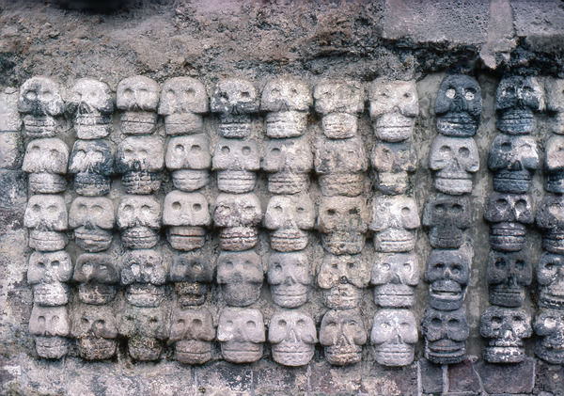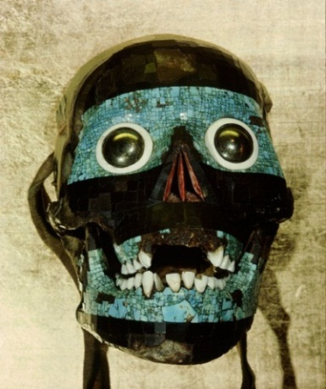
Figure 1 Skull Rack Tmplo Mayor, Mexico City figure 2 Mosaic Skull, mask of Tezcatlipoca
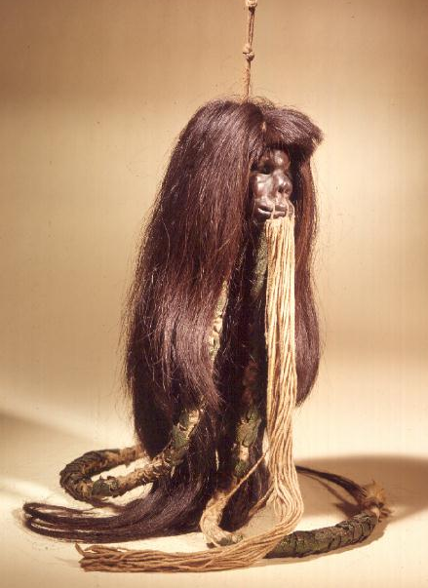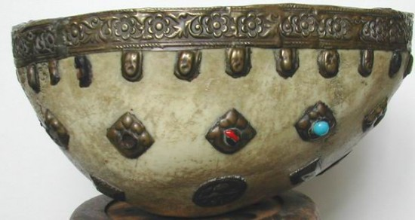
Figure 3 Shrunken Head Figure 4 Skull Cup
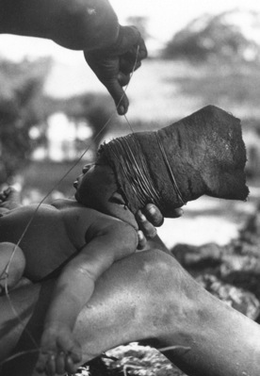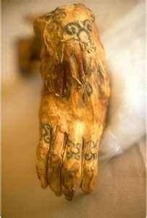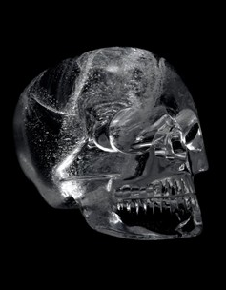
Figure 5 Head binding Papua New Guinea Figure 6 Egyptian tattoo figure 7 Rock Crystal Skull
Religious Art
The influence of Christianity in Medieval artwork was to affect figurative art. After the Influence of the Roman world and classical art, Christianity was to bring a less defined face to sculpture. Religious concerns over Idolatry meant that a less realistic style of sculpture was adopted, preferring to produce work that was recognisably human but with less individuality. Three dimensional work became less significant and non-figurative and two dimensional work became more significant. Illuminated manuscripts became very elaborate. Images were mainly religious, or of war, and faces were depicted unrealistically, flat, and with less sense of scale and proportion. Sculpture mainly took the form of reliefs or images of religious figures. The Renaissance brought with it greater use of realism, an understanding of perspective, and scientific study by Artists such as Botticelli, Raphael, Titian, Michelangelo, and Leonardo da Vinci. The Skull Iconography used in Templar Art may have more to do with broader traditional religious styles, especially in church architecture. Templars also used the symbol of Chi-Rho (Pronounced Cairo) (figure 8 Christian Chi- Rho Carving from sarcophagus ) thought to have originated from the Eyptian symbolism of the cross (X) as the pharaohs mummified crossed arms defensive pose protected themselves as they entered the next life, and the staff (P)(figure 9 King Tut sarcophagus). It was adopted as a symbol of early Christianity as Chi-Rho or XP are the first two Greek letters of ΧΡΙΣΤΟΣ or Christos (Christ), and as the X represented the cross as carried at an angle by Jesus. This symbol was used to meet secretly to worship avoiding persecution. Constantine brought it into popular use when he converted to Christianity.(figure 10 Roman Constantine coins with Chi-Rho topped banner)
The pirate flag, the “Jolly Roger” originally would have been plain red, then plain black and became more elaborate with many featuring a skull, sometimes with crossbones, hourglass or stabbed heart. The Jolly Roger would not be flown at all times but raised against another ship, inducing fear, which encouraged less resistance, but the symbolism of the skull itself may have had less to do with this sense of fear than the fact the flag stood for pirates. An alternative for the origin of the skull and crossbones jolly roger (figure 11 Jolly Roger featuring Skull and Crossbones) is that the Templar’s Chi-Rho was adapted to fit a new purpose, as unemployed Templars found a new career in Piracy, the Chi, or cross being symbolised by the crossbones. An alternate suggestion for the origin of the skull and crossbones design is discussed by Mary E. Miller’s Article Rethinking Jaina: Goddesses, Skirts, and the Jolly Roger; “Although various theories have been floated for the emergence about 1700 in the Caribbean of the banner known today as the Jolly Roger, it is worth considering that a pirate may have recovered Goddess O's skirt with its distinctive skull and crossed bones and then run it up the mast. Once seen, the iconography surely would have had resonance with all the skeletal imagery familiar to pirates in both fact and illustration: it may seem as if the iconography found the pirates, illuminating their own nature to themselves. Inadvertently, such acts linked pirates of the Caribbean to women warriors of the Maya past.” The skull and crossbones has recently been replaced in some areas of America on labels for poison and dangerous chemicals containers because of its link to pirates and the worry that children may be attracted rather than deterred.
Often as a result of relocating a large amount of skeletons, such as in the catacombs of Paris, Ossuaries or bone churches are visited due to interest not just in the history of the city, but in the arrangements and display of skulls and other bones that could be considered to be artistic but also offends many. If they are just bones, why is their display in this manner managing to cause offence? There are many ossuaries across Europe. The Czermna Chapel in Poland, the Monastery of San Francisco in Lima, the Capela dos Ossos in Evora Portugal, the San Bernardino alle Ossa in Milan Italy, and Our Lady of the Conception of the Capuchins in Rome. The Sedlec Ossuary, the Bone Church in Kutna Hora, Czech Republic (figure 12 Chandelier at Sedlec Ossuary) contains an estimated 40,000 dead (mostly plague victims). Bones decorate the church in a very ornamental fashion. We can bestow these bones with the life they had before, and consider if this is being respectful. Our tradition of burying the dead is one of many ways of disposing of the dead. Our way, the body is buried which guards against disease and animals. Some cultures such as in Tibet famous for sky burials, as the ground is too hard because of the climate and there is not enough wood for everyone to be cremated, it is the custom for bodies to be chopped up for the vultures. They are not offended by the use of the bodies in this way as death is seen as part of a cycle with the body no longer being needed. Plagues brought new fears of death, and new art, such as the Dance of Death or Danse Macabre, showing that Death comes to all, without bias. This style of Art was revisited by Hans Holbein the Younger, and engraver Hans Lutzelburger, in The Dance of Death. (figure 13 Death and the Duke, from The Dance of Death c.1538)
A reliquary is a receptacle for religious bones or artefacts and sometimes skulls, we often think of them as Catholic items, but in 2008 a piece of what is reported to be the Buddha's skull was discovered by archaeologists in Nanjing in a silver box inside a miniature pagoda that was thought to have been commissioned by Emperor Asoka. (figure 14 Miniature Pagoda and reliquary of part of Buddha's skull)
The Catholic Church has always had a strong connection with skulls. Golgotha and Calvary, names for the site of the crucifixion translate as the place of the skull. This may be because of the shape of the hill itself which looks like a skull. Paintings of the crucifixion sometimes feature the skull of Adam (of Adam and Eve) at its base, as it is said that Noah took Adam’s skull on the Ark during the flood and when the flood subsided buried it directly underneath Golgotha. When Jesus was crucified his blood seeped through the rock and cleansed the sins of Adam. (figure 15 Crucifixion Painting by Fra Angelico)
Crusaders took the bones (without the skull) of St. John Chrysostom, Archbishop of Constantinople, to be taken to the Vatican. Constantinople is now called Istanbul. The bones were returned by Pope John Paul II ; “And now, some of their relics - remains of those bodies that have followed in the footsteps of Christ, have suffered persecution for his Name and have lived as temples of the Holy Spirit - return to Constantinople” . As a result, there is more than one “Skull of St. John Chrysostom” on display in Europe. This can be said of other Saints also. The reliquary of the skull of Mary Magdalene in the Basilica of Mary Magdalene, St. Maximin la St. Baume, France is another example of a reliquary of a skull approved by the Catholic Church. The Skull is hidden from view when the skull is walked in procession through the streets by a golden mask of a face and flowing hair; the face is removed inside the church so people can view the skull. (figure 16 The reliquary of the skull of Mary Magdalene) These reliquaries often in heavily laden gold cases are at the centre of some debate. Questions of Idolatry arise, with the church defending the attention given to these skulls as an extension of the link to the word or actions of God through the Saints and not for the bones themselves. This dilemma can be linked to that of other religious Images, such as Vanitas Paintings.
The symbolic nature of the 17th Century Vanitas paintings was highly religious and displayed a strong message. Life was often represented through depictions of flowers or fruit, items would feature to represent the pleasures of life such as a musical instrument, and an hourglass or decay would represent the passing of time. The skull is identified with death. It sends a moral message of the transience of life and the importance of living a moral and religious life. This moral message displayed may be seen at odds with owning a Vanitas painting, (figure 17 Harmen Van Steenwyck Still life: An allegory of the Vanities of Human Life 1640)
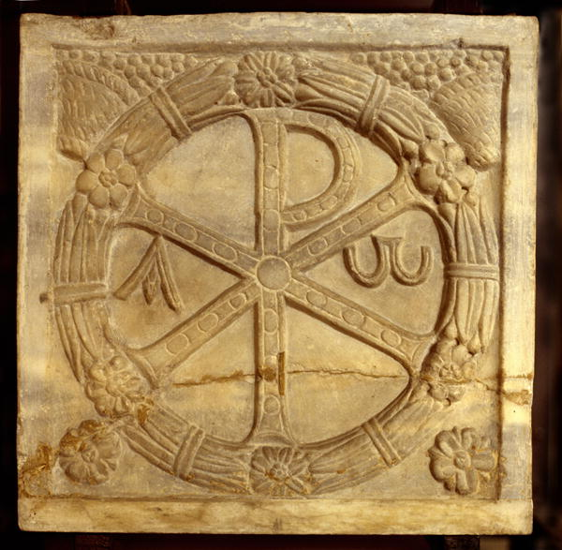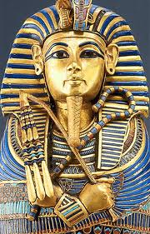
Figure 8 Christian Chi- Rho Carving from sarcophagus Figure 9 King Tut sarcophagus

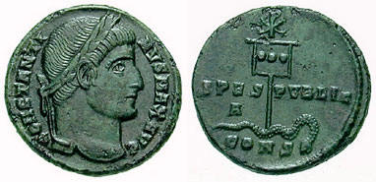
Figure 10 Roman Constantine coins with Chi-Rho topped banner Figure 11 Jolly Roger featuring Skull and Crossbones
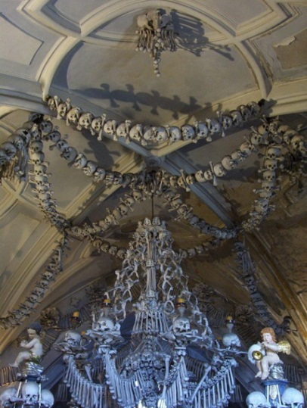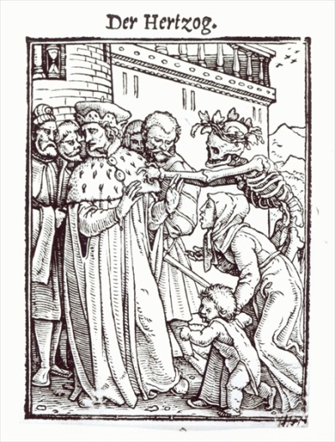
Figure 12 Chandelier at Sedlec Ossuary figure 13 Der Hertzog (The Duke) from The Dance of Death
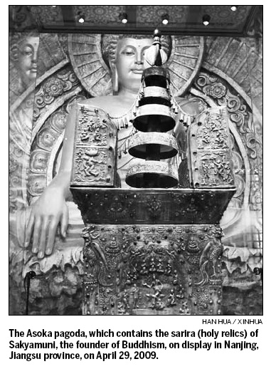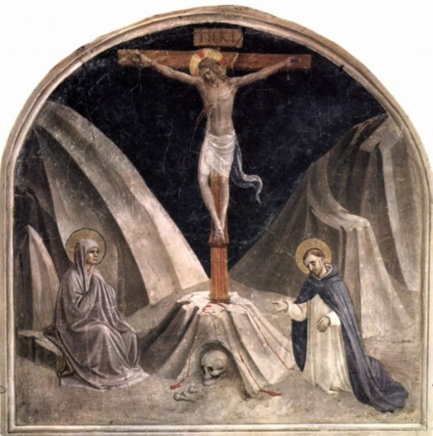
Figure 14 Miniature Pagoda and reliquary of part of Buddha's skull Figure 15 Crucifixion Painting by Fra Angelico
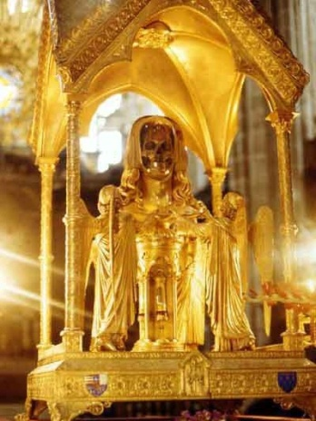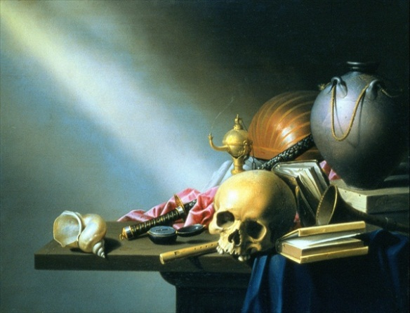
Figure 16 Reliquary of the skull of Mary Magdalene. Figure 17 Still life: An allegory of the Vanities of Human Life 1640
Anatomical Art
Many artists have studied the body, from life drawing and anatomy and even dissection. There are many famous studies of the skull from Leonardo da Vinci’s notebooks (figure 18 Leonardo Da Vinci, Anatomical Drawings ) to Henry Gray’s Anatomy of the Human Body in 1918, with illustrations by Henry Van Dyke Carter. (figure 19 Henry Gray, Anatomy of the Human Body 1918) These studies are scientific, unemotional, without meaning other than in further understanding of the human form and yet remain beautiful. These studies often would be an issue with the religious concerns of the time. Both Leonardo and Michelangelo were known to have undertaken autopsies which gave them knowledge of human anatomy that influenced their paintings. The flowing fabric behind God in Michelangelo’s Creation of Adam is thought to represent a brain which he would have studied during these autopsies. (figure 20 Michelangelo The creation of Adam)
As two dimensional scientific representations teach us about the workings of the body, three dimensional representations use this knowledge to show us faces lost by history. Facial reconstruction uses the skull and layers of muscle fat and skin are added to provide a likeness of the person. For forensic use, it is important that the face is as close to reality as possible for identification purposes and so although the skill level is high, artistic interpretation needs to be as little as possible. For archaeological use the artistic interpretation can be slightly higher, influenced by art or records of the time describing hairstyles, etc. Examples of this can be seen with work done on Egyptian mummies, such as the facial reconstruction of King Tut. (Figure 21 Facial Reconstruction King Tut)
Although disproved now the “science” of phrenology was very popular. It was believed that different areas of the brain controlled parts of the personality, and that by feeling the shape of the skull you could tell what areas of the brain was over or underdeveloped, and reveal information about the individual. This pseudoscience was used on the skulls of dead criminals to explain their behaviour. Today we know more about the brain, and yet ceramic phrenology busts still remain popular as a decorative item. ( figure 22 Ceramic Phrenology Bust)
The most famous wax figures are those of Madame Tussaud who was forced to make the death masks of guillotined aristocrats during the French Revolution. Although the need for these figures to be recognizable to the person they represent, they are still considered art, with tourists flocking to modern Madame Tussaud’s museums across the world (figure 23 Madame Tussaud Wax Works) Other wax works have had a harder time being accepted, the medical wax works of Gaetano Giulio Zumbo (figure 24 Preprati Anotomici 1695 Gaetano Guilio Zumbo) and others produced a way of studying anatomy when bodies were not available. Access to wax models helped medical students, but in themselves are viewed as macabre.
In 1801 James Legg was hung for murder. Sculptor Thomas Banks and painters Benjamin West and Richard Cosway took Leggs dead body and crucified it, the skin was then flayed by surgeon Joseph Constantine Carpue. Banks was then able to oversee the production of a plaster cast of the body to prove how a crucified body would look anatomically. Their reasoning was to improve the understanding of anatomy for use in paintings of the crucifixion. This is a tool of learning at the Royal Academy of Arts. ( figure 25 Anatomical Crucifixion of James Legg, 1801 Plaster cast)
After several cases of body snatchers or resurrection men being caught and hung for not just digging up bodies but committing murder to provide bodies to medical schools. The 1832 Anatomy Act was brought in allowing “unclaimed” bodies to be used for dissection. This was unpopular, as previously murderers were dissected so there was a stigma attached, and there was a worry people would neglect their relatives, or would themselves fall into poverty and have the state claim their body against their wishes. As a result a popular Art of the time was satirical drawings of resurrection men, over enthusiastic doctors, bodies, skeletons, and fearful patients. These included the work of Thomas Rowlandson. ( figure 26 Thomas Rowlandson Death in the Dissection Room)
Polymer preservation or Plastination of bodies as in the work of Gunther von Hagens has also had this reaction. These had more ethical considerations as they were not copies of bodies, was it respectful of the dead? The bodies were not left lying still as with the wax models, but in poses. Consent was given by people in Germany who donated their bodies to this process, but Hagens does not believe consent is needed were single organs are used. Plastination is also used in some medical, dental and veterinary schools in the same way as wax models, for teaching anatomy. So does the “Art” of Hagen’s displays and other anatomical works come down to where it is exhibited? If we are learning does it stop being Art, and what are we supposed to be learning. This is one of the concerns made of Hagen’s work, as with Damien Hirst’s formaldehyde animal sculptures, although Hagen’s work being human, affects attitudes differently. Qualified Users can purchase a body for 69.615,00 Euros. “Apart from a large number of products we supply specimens of human body parts. Human Anatomical Teaching Specimens are provided for medical education and/or research only. The Gubener Plastinate GmbH commits itself to sell human specimens only to insitutions or indiviudals which use these specimens exclusively for research and educational purposes or for medical, diagnostical and therapeutic education (by definition qualified user).” Although it is not the donated body that is being bought, but the Plastination process that it has gone through, there are ethical questions that would not arise if no human body was involved, such as the selling of a wax model.
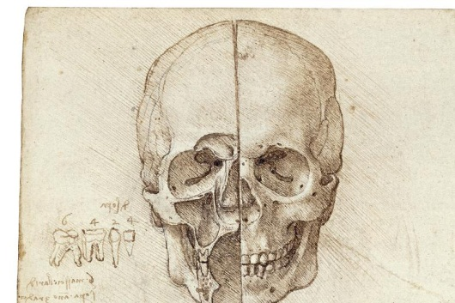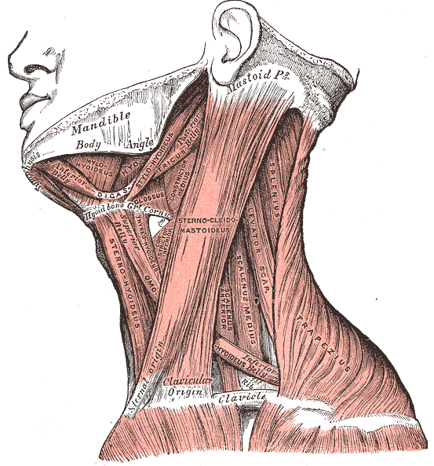
Figure 18 Leonardo Da Vinci, Anatomical Drawings Figure 19 Henry Gray Anatomy of the Human Body 1918
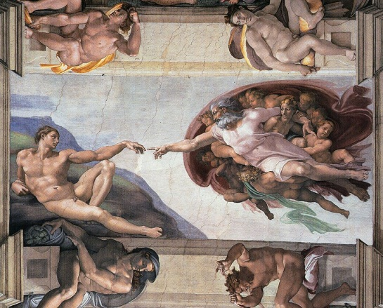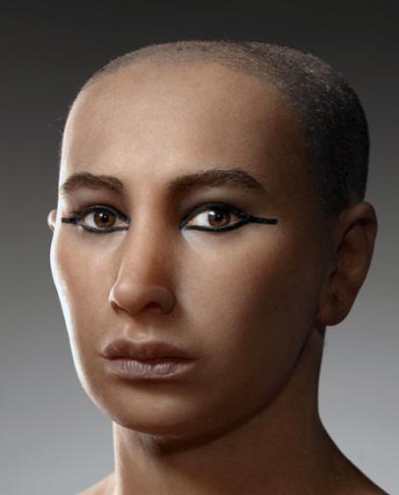
Figure 20 Michelangelo The creation of Adam Figure 21 Facial Reconstruction King Tut
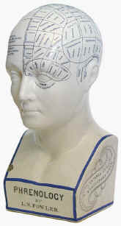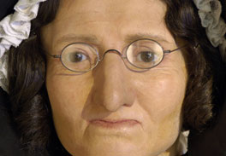
Figure 22 Ceramic Phrenology Bust Figure 23 Madame Tussaud Wax Works
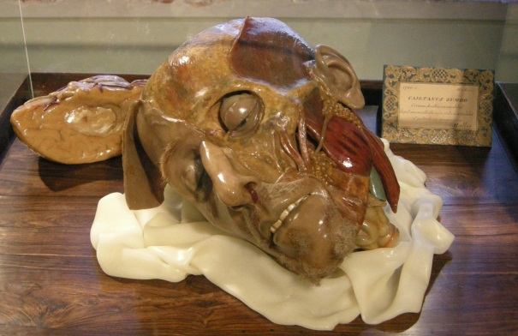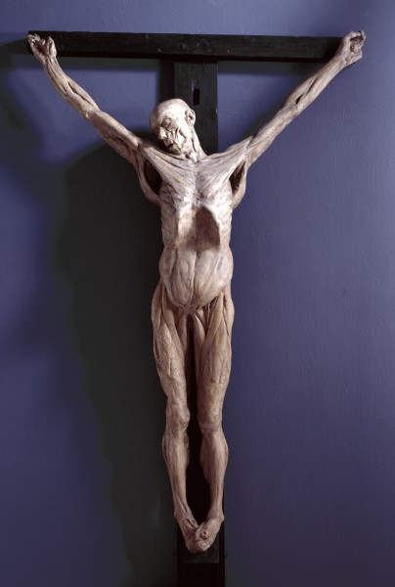
Figure 24 Preprati Anotomici 1695 Gaetano Guilio Zumbo Figure 25 Anatomical Crucifixion (James Legg), 1801 Plaster cast)
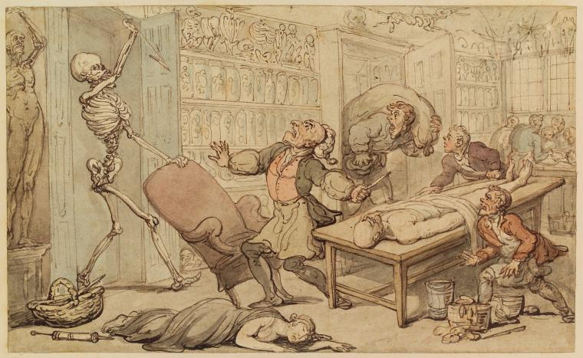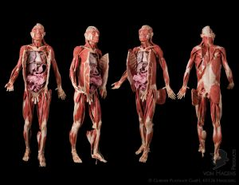
Figure 26 Thomas Rowlandson, Death in the Dissecting Room figure 27 Plastinate figures

Cultural Art
In modern Mexican religion one folk saint has gained many followers in today’s culture. The visual representation of Santa Muerte (Saint Death) is explained by Andrew Chestnut in his book devoted to death; “most Americans and western Europeans would immediately recognize Sant Muerte as a sort of female Grim Reaper with origins in medieval Catholicism. Spaniards wouldn’t even have to make allowances for her gender since their own personification of death, known as La Parca, is a female skeleton. Mexicans, however, are more likely to regard the skeleton saint as an adapted version of an indigenous goddess (usually Aztec or Mayan) of death. As odd as this may seem to foreign observers, for many Mexicans the realities of indigenous history and myths of nationalism converge to give the White Sister a local birthplace in pre-Columbian Mexico”
Mexican art appears to be highly influenced by its Aztec (Mexica) roots, The Day of the Dead festival in Spain and Mexico honours the dead and features the skull,(figure 28 Day of the Dead by modern mexican muralist Joaquin Alejandro Newman ) as Spanish Catholics attempted to replace indigenous celebrations with more “suitable” observances of all saints and all souls day, much in the same way as our Christmas was originally a pagan celebration. Placing one festival on top of another was easier than eradicating it. Spanish cemeteries have historically had real skull and crossbones marking its entrance. The impact of the sugar skull in modern popular culture has become a much repeated symbol, especially in tattoos and clothing. Although sugar skulls seem to link back to an Aztec Tradition of decorated skulls there appears to be no historical connection and it is more closely linked to the Spanish Catholic influence and may have its origins in Italy. Sugar was abundant and was a way to make alter decorations cheaply. Also Modern Mexican skull art often is satirical in nature and increasingly uses full skeletons enacting humorous scenes from life.
José Guadalupe Posada was an illustrator, who used his art to draw attention to societies inequalities. La Calavera Catrina, is an image created by José Guadalupe Posada, a Mexican illustrator but re-invented in all art forms. Posada was making a statement about cruel working conditions.(figure 29 La Calavera Catrina , Zinc Etching Jose Guadalupe Posada 1910-1913)
Paul Gauguin who had painted Arri Matamoe (figure 30 Paul Gauguin Arri Matamoe( the royal end) 1892 ) very early on, would continue working in Primitivism with figurative art in bold colours. He stated “ I have just finished a severed kanak [Pacific Islander] head, nicely arranged on a white cushion, in a palace of my invention and guarded by women also of my invention”.—Quote from a letter by Paul Gauguin to Daniel de Monfreid
Paul Cézanne was a link between the post impressionists and cubist painters. At the end of his life Cézanne turned to Catholicism, this may be the influence behind his still life paintings of skulls including three skulls in 1900, and pyramid of skulls painted five years before his death. (figure 31 Paul Cezanne Three Skulls 1900)
Pablo Picasso admired the work of Paul Cézanne. Picasso produced a large number of still life paintings with skulls reminiscent of the vanitas paintings. Picasso adopted many styles through his lifetime including Cubism. Picasso was also part of a group of artists exploring Primitivism who were not only influenced by their own culture but drew on inspiration from the work of other cultures, tribal art from Africa played a large role in the style of representation of the figure.(figure 32 Pablo Picasso Skull with Leeks 1945)
Frida Kahlo was born three years before the Mexican revolution, and had a catholic upbringing; she was influenced by a strong connection to her Mexican heritage and nationalism, as well as the religion of her childhood. Kahlo’s work was often biographical, based on the injuries she suffered from the bus crash she had when she was 18, and subsequent surgeries, as well as her turbulent relationship with husband and fellow artist Diego Rivera who specialised in nationalistic anti-war murals. Kahlo’s self-portraits often used symbolism and surrealism, and the colours of primitive paintings. Her painting “Girl with a death mask” is supposed to portray a young Frida unaware of her life to come. (figure 33 Frida Kahlo Girl with a death mask 1938)
In 1938 Andre Breton travelled to Mexico and worked with Leon Trotsky and Diego Rivera on the "Manifesto for an Independent Revolutionary Art." In 1939 Breton was behind an exhibition of Mexican Art called Mexique at the Louvre in Paris. Following this exhibition the Louvre bought self-portrait - the frame, a painting by Frida Kahlo, the first by a 20th century Mexican Painter.
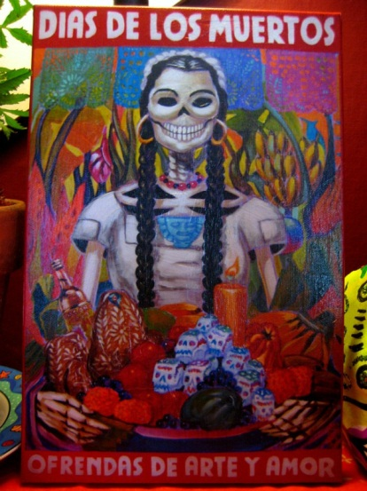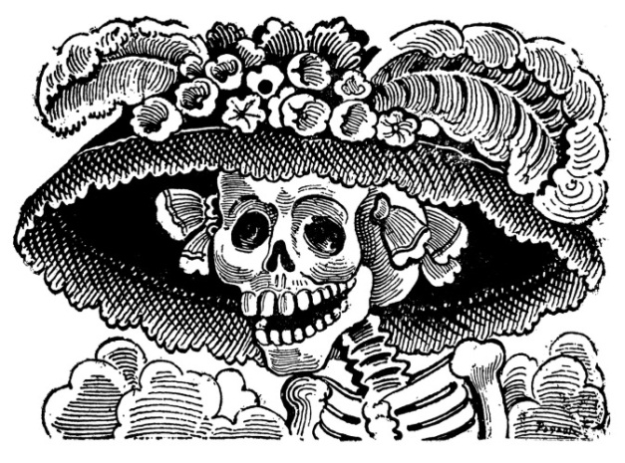
Figure 28 Day of the Dead Joaquin Alejandro Newman Figure 29 La Calavera Catrina Jose Guadalupe Posada
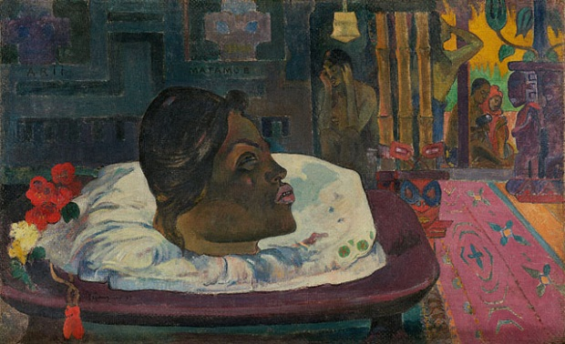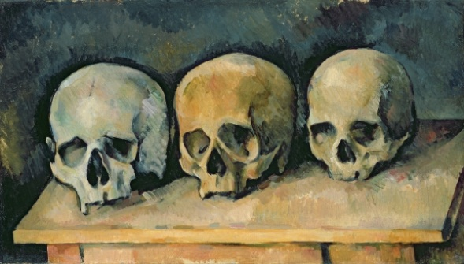
Figure 30 Paul Gauguin Arri Matamoe( the royal end) 1892 Figure 31 Paul Cezanne Three Skulls 1900
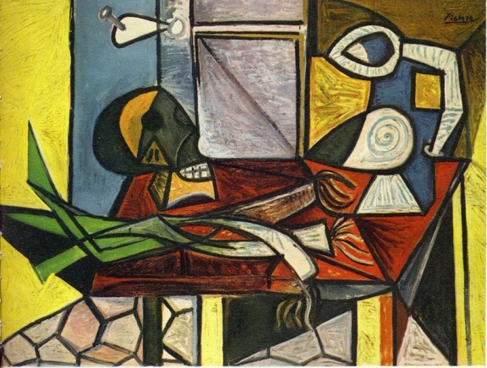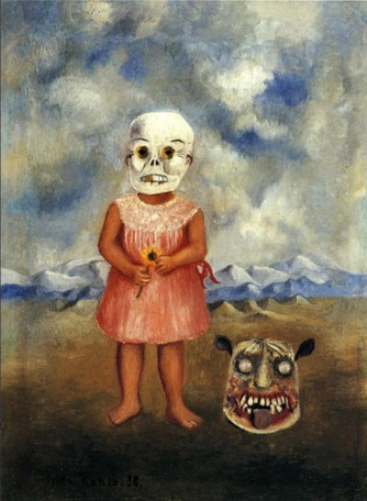
Figure 32 Pablo Picasso Skull with Leeks 1945 Figure 33 Frida Kahlo Girl with a death mask 1938

Conclusion
The use of skulls, bones and bodies is widespread throughout history. By looking at examples I have been able to see that although through a modern Western viewpoint we see these things as macabre and as images of death. This is a view that is altered by our cultural ideas, our ways of connecting to the dead. Sometimes these things do represent death. In the skulls of the Vanitas Paintings, they are a memento mori, a reminder of a person’s mortality, as guidance as to how to conduct a moral life. Death is a part of life, a transition which is why the Buddhist values bring a different symbolism to the skull. In other cultures Skulls are used as propaganda, a warning that death could be the result of being an enemy, or doing the wrong thing, just as in the skull and crossbones version of the Jolly Roger pirate flag, or how we use skulls in the warning labels on chemicals. For many the Crystal skulls are an image of knowledge rather than death. Reliquaries provide a connection to a person’s faith, many believing in the reliquaries having healing powers. Gunther Von Hagens uses his plastination techniques to show us more about our own bodies as did the wax models and anatomical drawings that preceded his artwork. While Gauguin took pleasure in the shock value his portrayal of death could achieve. Is it too easy to say that skulls only represent death? Skulls bones and bodies all illustrate a death, as without death the skull bones and internal structures of the body would be hidden from us, and yet the imagery can also represent the soul, power, knowledge or life that inhabits us. It is important when looking at an individual artwork that we also consider the religious or cultural context in which it was made before we can fully understand its meaning.
Maybe we should be asking instead why is Art that is about death viewed as morbid, often unethical, and slightly unnecessary. Why do we want to ignore that death comes to all whatever our status as the Vanitas paintings tell us, or that death is a part of life, as the Tibetan artists have told us. Mexican Day of the Dead Art, which isn’t afraid to celebrate death or remember the Dead, shows us we shouldn’t be afraid of talking about Death, or producing Art which relates to Death. The Crucifixion, so often depicted in Catholic Art, is seen in a different light. Perhaps this is because we know that in the next scene is the resurrection, so this death is a stage that is not permanent, and so, less confrontational, or that the Religious meaning of a sacrifice for our benefit is more hopeful. Perhaps its image is just an accepted part of our culture and history. We are not so willing to discuss our own death, or see death portrayed in Art, as it asks us to face our own mortality. Yet certainly the popularity of exhibitions such as Death: A self-portrait at the Wellcome Collection and Doctors, Dissection and Resurrection Men at the Museum of London prove that an interest and curiosity exists today for the Art of Death.
Research Trips
The Pitt Rivers Museum, Oxford
The British Museum, London
The National Museum of Cardiff Wales
The Museum of London, London Exhibition Doctors, Dissection and Resurrection Men
The Wellcome Collection, London Exhibition Death: A self-portrait
Bibliography
Beér Robert. Tibetan Symbols and Motifs,Chapter Eleven, Wrathful offerings, tormas and ritual fire hearths - The six bone ornament and the five skull crown P319-320
Before Cortés: Sculpture of Middle America, 27-29.
Bumpus, Barnaby. The Dublin Penny Journal, Vol. 1, No. 5 (Jul. 28, 1832), Verses Inscribed by a Phrenologist on a Skull p. 40
Chesnut, Andrew. Devoted to Death: Santa Muerte, the Skeleton Saint Chapter 1,P27 -28
De León, Ann. MLN125. 2 (Mar 2010): Coatlicue or How to Write the Dismembered Body 259-286.
Eckardt Ledes, Allison. The Magazine Antiques, 170. 3 (Sep 2006): 20,22. Medieval faces
Haslam, Fiona. From Hogarth to Rowlandson: Medicine in Art in Eighteenth-Century Britain
Hirst, Damien. Tate Etc 24 (Spring 2012): "Death has not required us to keep a day free"
Kessler, Herbert L.. Art Bulletin, June 1988, Vol. 70, , 22p; DOI: 10.2307/3051115October 2003) p166-187
King, Heidi. "Aztec Stone Sculpture". In Heilbrunn Timeline of Art History, New York: The Metropolitan Museum of Art, 2000– http://www.metmuseum.org/toah/hd/azss/hd_azss.htm (On the state of medieval art history.
Leighten, Patricia. The Art Bulletin, Vol. 72, No. 4 (Dec., 1990), The White Peril and L'Art nègre: Picasso, Primitivism, and Anticolonialism pp. 609-630
Lightbown R.W. The Burlington Magazine, Vol. 106, No. 740, Nov., 1964, Gaetano Giulio Zumbo, 1:the Florentine period, p486
Lomnitz, Claudio, Death and the Idea of Mexico
MacLaren Walsh, Jane. Archaeology Archive: A publication of the Archaeological Institute of America , May 27 2010, The Skull of Doom - http://archive.archaeology.org/online/features/mitchell_hedges/
Marchi, Regina M, Day of the Dead in the USA. The Migration and Transformation of a Cultural phenomenon chapter 2 Mexico’s special relationship, p21-33.
The Metropolitan Museum of Art Bulletin,New Series, Vol. 29, No. 3 (Nov., 1970), pp. 138-150
Miller, Mary E. Record of the Princetown University Art Museum; 2005, Vol.64, Rethinking Jaina: Goddesses, Skirts, and the Jolly Roger. P63-70
Ryan, Richard. Commentary, 93.5 (May 1992): 41. 1492 and All That
Schjeldahl, Peter. The New Yorker, 80.33 (Nov 1, 2004): MEMENTO MORI; THE ART WORLD
Sax Margaret, Walsh Jane M., Freestone Ian C., Rankin Andrew H., Meeks Nigel D Journal of Archaeological Science (abstract) Volume 35, Issue 10, October 2008,–2760 The origins of two purportedly pre-Columbian Mexican crystal skulls. - Pages 2751 http://www.sciencedirect.com/science/article/pii/S0305440308001052
Udall, Sharyn R. Woman's Art Journal, Vol. 24, No. 2 (Autumn, 2003 - Winter, 2004), Frida Kahlo's Mexican Body: History, Identity, and Artistic Aspiration, pp. 10-14
Wellcome Collection, Death, A Picture Album
Wilkinson, Caroline. US National Library of Medicine National Institutes of Health J Anat. 2010 February; 216(2): doi: 10.1111/j.1469-7580.2009.01182.x Facial reconstruction – anatomical art or artistic anatomy? 235–250

Websites
BridgemanEducation http://www.bridgemaneducation.com.ezproxy.uwic.ac.uk/
The British Museum, - http://www.britishmuseum.org/
Gubener Plastinate http://www.plastination-products.com/index.php
J. Paul Getty Museum – Gauguin Arii Matamoe http://www.getty.edu/art/gettyguide/artObjectDetails?artobj=310277
madametussauds - http://www.madametussauds.com/London/About/History/Default.aspx
The Mitchel-hedges crystal skull Official Website - http://www.mitchell-hedges.com/
The Museum of London, - http://www.museumoflondon.org.uk/London-Wall/Whats-on/Exhibitions-Displays/Doctors-Dissection-Resurrection-Men/
Museum of modern art (MOMA New York) - http://www.moma.org/
National Geographic, Photo in the News: King Tut's Face Reconstructed - http://news.nationalgeographic.com/news/2005/05/0510_051005_tutsface.html
The Pitt Rivers Museum, Oxford - http://www.prm.ox.ac.uk/
The Royal Collection, The Queen's Gallery, Buckingham Palace, Leonardo da Vinci: Anatomist - http://www.royalcollection.org.uk/exhibitions/leonardo-da-vinci-anatomist
San Francisco Museum of Modern Art, Video, the manifesto for an independent revolutionary art http://www.sfmoma.org/explore/multimedia/videos/49
Sedlec Ossuary - http://www.sedlecossuary.com/
La Specola, Museum of Natural History, Florence - http://www.museumsinflorence.com/musei/museum_of_natural_history.html
Vatican (Rome) - http://www.vatican.va/
Vatican (Rome) -Ecumenical celebration on the occasion of the transferral from Rome to Constantinople of the relics http://www.vatican.va/holy_father/john_paul_ii/letters/2004/documents/hf_jp-ii_let_20041127_consegna-reliquie_en.html
The Wellcome Collection, - http://www.wellcomecollection.org/whats-on/exhibitions/death-a-self-portrait.aspx
The Wellcome Library - http://library.wellcome.ac.uk/

Pitt Rivers Museum Website
Record of the Princeton University Art Museum; 2005, Vol. 64, p63-70,
ECUMENICAL CELEBRATION ON THE OCCASION OF THE TRANSFERRAL FROM ROME TO CONSTANTINOPLE OF THE RELICS OF STS GREGORY OF NAZIANZEN AND JOHN CHRYSOSTOM : LETTER OF JOHN PAUL II TO THE ECUMENICAL PATRIARCH OF CONSTANTINOPLE HIS HOLINESS BARTHOLOMEW I (Vatican Website)
http://www.plastination-products.com/index.php
Andrew Chesnut. Devoted to Death: Santa Muerte, the Skeleton Saint, Chapter 1,P27 -28
J Paul Getty Museum Website

