Kayn Lewis (2014)

Does the depiction of Death in Art, mirror modern society’s relationship with death?
A Degree level Dissertation

Contents
1. Introduction 1
2. What is Death ? 2
3. Social influences 7
3.1. Historical Influences of Religion on Britain 7
3.2. Plague, Disease and Death 11
3.3. Anatomy Act 15
3.4. NHS and Death 16
4. Depicting Death 20
4.1. Untimely Death 21
4.2. September 11th 2001 24
4.3. Famous Deaths 31
4.4. Public Death 34
5. An Individual Death, Post-Mortem Choices 38
5.1. Preparations 38
5.2. Victorian Post Mortem photos 39
5.3. Remembrance 40
5.4. Alternative endings 44
5.5. Embalming 48
6. Death in Art 50
6.1. Embalming Art 50
7. Conclusion 55
8. References 58

List of Figures
Figure 1- Steven Gregory, Skulduggery (2003) 3
Figure 2 - Section of the Bayeux Tapestry 8
Figure 3 - 20th Century Death (2013) 13
Figure 4 - The 10 leading causes of death in low income countries (2011) 15
Figure 5 - The 10 leading causes of death in high income countries (2011) 15
Figure 6 - Photograph by Roger Fenton , Crimean War (1855) 21
Figure 7 – Photograph by Pablo Bartholomew, Bhopal Gas Tragedy (1984) 22
Figure 8 - Poster for “The Impossible” (2012) 24
Figure 9 – Photograph by Lyle Owerko on Cover of Time Magazine, showing September 11th WTC attacks 25
Figure 10 – Photograph by Mark Lennihan, The Tribute in Light shines above reflecting pool at 9/11 Memorial 28
Figure 11 - Eric Fischl, "Tumbling Woman" (2001) 29
Figure 12 - To The Struggle Against World Terrorism by Zurab Tsereteli (2006) 30
Figure 13 – Memorial by Heath Satow (2011) 31
Figure 14 - Attachment by Edwin Henry Landseer (1829) 32
Figure 15 - Photograph by Dennis Stock (1955) 32
Figure 16 - Keep a Child Alive Charity Campaign Poster (2010) 33
Figure 17 - The assassination of President Lincoln by Currier and Ives (1865) 34
Figure 18 - Frame 312 from the Zapruder film of the JFK assassination (1963) 34
Figure 19 - Falls Road in West Belfast (2013) 35
Figure 20 - Effigy of Margaret Thatcher that was burnt by miners in Goldthorpe, South Yorkshire(2013) 35
Figure 21 - Death mask of Napoleon Bonaparte (1821) 36
Figure 22 - Gravestone of Spike Milligan (2004) 42
Figure 23 - Einstein’s Brain 45
Figure 24 – Matt Groening, Still of Futurama, animated TV series 46
Figure 25 - Photograph of Elmer McCurdy 47

Does the depiction of Death in Art, mirror modern society’s relationship with death?
Death in Art or Art in Death ?

- Introduction
Does the depiction of Death in Art, mirror modern society’s relationship with death? As Death is a large subject in Art, this dissertation will deal with key areas;
- What do we mean by Death,
- The social influences on society’s relationship with Death and how these have been formed over time through our history, focusing on History, Religion, and Medicine.
- How we depict death, especially in a modern world with modern technology.
- What decisions we make about our death, and how we choose to individualise it.
- Representing Death in Art, and issues of preservation or Death of Art.
Death has been represented in a variety of ways, not all figurative, which this dissertation will focus on. As a ceramicist, working figuratively and often producing representations of skulls, it is important to find out how this type of artwork is viewed. The aim of this dissertation is to discover how a society’s history influences its representation of Death in Art, and how our expected reaction to these depictions are used by artists wanting to carry a message, provoke an emotional response or make a social commentary. In contrast, how does our society’s relationship with Death affect Art through censorship; exploring what is and is not acceptable when depicting Death, and whether this is dependent on the medium used, or when and where it is displayed.

- What is Death ?
This section will consider society’s relationship with Death. The Wellcome Collection has recently held an exhibition of the collection of Richard Harris called “Death: A Self-Portrait”. Harris said of his collection;
"Death has been a very important subject in art, and one that has meaning for all of us," Harris said. "All of these pieces stand in their own right as works of art, but if they persuade the public to engage with a subject too often kept at a distance, so much the better."
Harris speaks of a wish for the public to “engage” with the subject of Death. While the public may have difficulties in discussing Death, the subject is often openly explored by artists. Frida Kahlo said;
“I would not want to die as a hero or as a coward. I think about death very often; too much. I wanted to die out of desperation. I thought of suicide in 1935 and another time a year ago [1949]. I tried it the second time. I would recommend barbiturates, to fall asleep. The relationship between love and death is dialectic: they are opposites. I do not believe in life after death. It bothers me to see a cadaver. I do not know what I would do if I were told I had one hour to live. I imagine that if I were dying I would be thinking of Diego. The death of loved ones is the thing that terrifies me the most. The death that moves me the most is the slow death of a young person - anyone.”
This level of candor is not unusual for Kahlo, but may be unusual for most when discussing Death. In “Skulduggery: On Steven Gregory//2005”, Damien Hirst writes of Gregory’s Work:
“My own personal favourite are the real human skull and bone pieces, (Figure 1) where, just as many humans and pre-humans have done before us for tens of thousands of years, he uses decoration to try to deal with the complexity of human death, a brave attempt to celebrate the unimaginable. I don’t understand death, don’t think any of us do, I doubt we ever will, but let’s never stop trying.”

Figure 1- Steven Gregory, Skulduggery (2003)

Hirst is asking: What is Death? This question may produce a variety of answers. Death is the unknown, it is the end of this life. For some it is a complete full stop, while for others an end for the body only and a transition to either another life, or an afterlife. Because Death comes to us all, and yet remains a mystery, it cannot be described easily as being one thing. In medical terms, due to the ability to have ventilator machines keeping people alive indefinitely, Death has been specified as brain death, when the brain stem stops functioning. The NHS clarifies how brain death constitutes actual Death;
“ The brain stem is responsible for regulating most of the automatic functions of the body that are essential for life. These are: Breathing, heartbeat, blood pressure, swallowing. The brain stem also relays all information to and from the brain to the rest of the body, so it plays a fundamental role in the brain’s core functions, such as consciousness, awareness and movement. There is no possibility for consciousness once brain death has occurred and in combination with inability to breathe or maintain bodily functions this constitutes death of the individual.”
In his book “The Lazarus Effect: The Science That is Rewriting the Boundaries Between Life and Death”, Dr Sam Parnia claims that “we now know that death is reversible.” This is to say that people who “die” due to a cardiac arrest, if caught early enough (prior to brain death ) with proper medical care, can now be brought back by cooling the body to halt decay, and repairing the blood flow/oxygen supply no longer maintained by the heart using an ECMO (extra corporeal membrane oxygenation) machine, and then fixing the cause of death (clearing blockages etc.), allowing the patient once resuscitated to return to a normal life. The combination of cooling and using the ECMO stops the body from deteriorating while the cause of death is treated. In an Interview with Tim Adams for The Observer, Parnia states;
“ . . . every area of inquiry that used to be tackled by religion or philosophy is now tackled and explained by science. One of the last things to be looked at in this way is the question of what happens when we die. This science of resuscitation allows us to look at that for the first time."
This shift from society looking to Science, and Medical advancements, rather than God and Religion has been gradual but has had a wider influence on our relationship with Death. The connection the Church has had to our understanding of the world, has also impacted Art through history, from what should be represented, and what should not. In contrast, a good example of Death, Art and Medical exploration is found in the anatomical drawings of Artists such as Leonardo Da Vinci taken from dead autopsied bodies.
Another Artist associated with Death and Anatomy, because of his use of donated dead bodies is Gunther Von Hagens who uses Polymer preservation or Plastination of bodies. These had ethical considerations as they were not copies of bodies, was it respectful of the dead? The bodies were not left lying still as with the wax models, but in poses. Consent was given by people in Germany who donated their bodies to this process, but Hagens does not believe consent is needed were single organs are used. Plastination is also used in some medical, dental and veterinary schools in the same way as wax models, for teaching anatomy. So does the “Art” of Hagen’s displays and other anatomical works come down to where it is exhibited? If we are learning does it stop being Art, and what are we supposed to be learning. This is one of the concerns made of Hagen’s work, as with Damien Hirst’s formaldehyde animal sculptures, although Hagen’s work being human, affects attitudes differently. Qualified Users can purchase a body for 69.615,00 Euros.
“Apart from a large number of products we supply specimens of human body parts. Human Anatomical Teaching Specimens are provided for medical education and/or research only. The Gubener Plastinate GmbH commits itself to sell human specimens only to institutions or individuals which use these specimens exclusively for research and educational purposes or for medical, diagnostical and therapeutic education (by definition qualified user).”
Although it is not the donated body that is being bought, but the Plastination process that it has gone through, there are ethical questions that would not arise if no human body was involved, such as the selling of a wax model. In his series “Autopsy: Life and Death” Von Hagens introduced the program, Lesson 1- Blood by asking;
“How do you imagine your own Death? Will it be peaceful? Will it be quick? Will you be old? Our Death is a mystery to us. We cast it as an outsider, a thief, robbing us of our breath in an instant without warning. But death is less mysterious than we imagine. Its origins are in our genes, in the things that happen to us, in what we do”
Von Hagens brings the subject of Death into Art through his exhibitions, but then He reminds us that his work explores Death as having a cause which can be assessed through Autopsy. In Lesson 4 -Time, an episode in the same series, Professor John A Lee comments;
“We have introduced the idea of Death as increased vulnerability, as reduced ability to survive, but what are the possible ways which we can die. . .”
This episode discusses the fact that people who die of “old age” do have an initial cause of death which can be discovered through autopsy. Lee states;
“Especially in old age you often get a situation a bit like a domino effect, so one organ beginning to fail impinges on all the other organs which are the team that makes up our bodies and so you end up dying of a multiple organ failure effect.”
To die of old age has often been referred to as a “good death” but It shall be discussed later whether this is still the case. In Japan, one suicide occurs every 15 minutes, and yet suicide remains taboo, as suicide is considered a “bad death”. Japanese train lines refer to the frequent suicides at stations as “Human Incidents” when dealing with the 20 minute delay each one causes. This use of terminology, that hides the reality of death, can be used often when discussing death, often in an attempt to consider someone else’s feelings. The variety of language describing Death was the basis of the popular “Dead Parrot sketch” by Monty Python’s Flying Circus, performed from the 1970’s onwards, even being referenced by Margaret Thatcher in 1990 to describe the new Liberal Logo and the Liberal Party itself as being Dead. We can understand the connection when Life and Death are used to describe something that has never been biologically alive. This act of personification, allows Death to be a throw away line, i.e.”My car died” and yet Human Death whether our own, or of someone else, becomes more difficult to talk about. Has Death become unrelatable, often pictured as a Grim Reaper figure rather than the inevitable natural conclusion to life.
This Chapter discussed: what is Death? It has found that the clearest definition stems from a medical viewpoint, but that this definition only deals with the cause of death, the moment of death, and the fact of death. It does not define how the individual relates to Death, and that alternate terminology is often used to disconnect from the reality of Death. This dissertation will consider; what influenced modern society's relationship with Death, how we depict Death in Art and Media, what choices we make for our own Death, and how this impacts our relationship with Art, especially when Art represents Death. The next chapter will look at how religion, health, sickness and medical advancements have impacted societies relationship with Death.

- Social influences
This dissertation asks Does the depiction of Death in Art, mirror society's relationship with death? The last chapter discussed what is meant by the term “Death”. This chapter will look at how society’s relationship with Death has been influenced through history by Religion and Medicine.

  - Historical Influences of Religion on Britain
The history of Britain is built up of layers of influences from different cultures and religions. Religion affects all aspects of culture, including its relationship with Death. British religion began with ancestor worship, religious change occurred after a dramatic climate change in 3,000 BC led to people worshipping nature. Stonehenge was built and rebuilt over several hundred years. Adaption to Celtic religions or Paganism was followed by Roman invasions. First by Julius Caesar, in 55 BC, unsuccessful he returned in 54 BC .Claudius was the first to achieve a Roman Occupation of Britain beginning in 43 AD. Roman religion was polytheistic and accepting of other religions allowing for a mixture of Roman and pagan beliefs. Constantine’s conversion to Christianity meant people would not be persecuted for admitting their Christian beliefs but was only baptised on his death bed in 337AD. Britain saw Christian festivals occurring over pagan festivals. In 410 AD what remained of the Roman Empire, no longer being able to defend Britain had retreated. This was regarded as the Early Middle Ages, also called the Dark Ages, as there was a belief that after the departure of Roman rule, British Culture suffered.
The influence of Christianity in Medieval artwork was to affect figurative art. After the Influence of the Roman world and classical art, Christianity was to bring a less defined face to sculpture. Religious concerns over Idolatry meant that a less realistic style of sculpture was adopted, preferring to produce work that was recognisably human but with less individuality. Three dimensional works became less significant and non-figurative and two dimensional work became more significant. Illuminated manuscripts became very elaborate. Images were mainly religious, or of war, and faces were depicted unrealistically, flat, and with less sense of scale and proportion. Sculpture mainly took the form of reliefs or images of religious figures.
In the 5th Century, the Angles and Saxons, Germanic tribes, migrated to Britain in great numbers, and became known as Anglo-Saxon. Anglo-Saxon Britain was left open to attack from Viking invasion from Norway to Scotland, and Denmark to England, and was defended by King Alfred the Great. The Vikings had first made raids on Britain and went on to establish settlements such as York. They were Pagan, but they also adopted Christianity, Pagan Viking burials contain grave goods, while Christian Viking burials do not. This Period was followed by Norman Conquest after Alfred’s Death. The Norman Conquest including the Battle of Hastings in 1066, is famously depicted on the Bayeux Tapestry (Figure 2).
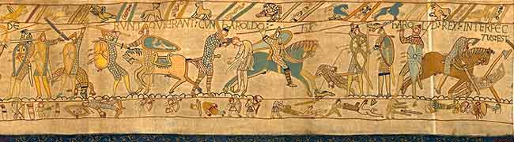
Figure 2 - Section of the Bayeux Tapestry

The Renaissance ( 14th-17th century), which began in Italy but expanded across Europe, would later bring with it greater use of realism, an understanding of perspective, and scientific study by Artists such as Botticelli, Raphael, Titian, Michelangelo, and Leonardo da Vinci.
The period between the reign of Henry the 8th and Mary the 2nd, 180 years later, saw great upheaval in Britain, in which Religion played a large role. Henry the 8th was given the title of Defender of the Faith in 1521 by the Pope, it is a title which has stayed with the Monarchy since then.
The reformation is often thought of as the story of King Henry 8th divorcing Catherine of Aragon but it was a broader movement across Europe. Martin Luther was a German monk whose followers became known as Lutherans he promoted the view that the bible should be accessible, that sins were forgiven for believing in God and did not require purchasing from a corrupted church through payment, and he married, setting a precedent. John Calvin was a theologian and reformist who wrote the Institutes of Christian Religion, his followers were called Calvinists. Henry was Catholic and fought against Lutheran views. Henry became King after the Death of his father, and took his brother Prince Arthur’s widow Catherine of Aragon as his first wife. Catherine gave birth to Princess Mary but Henry wanted a son, his requests for an annulment were refused by the Catholic Church in Rome. Henry moved the English Church away from the Catholic Church, he married Anne Boleyn who gave birth to Princess Elizabeth.
This period of history changed the relationship between the church and state, and would see the dissolution of the monasteries. Holy Trinity Church in Rothwell, Northamptonshire and St Leonard's Church, in Hythe, Kent are the only two British Ossuaries or Bone Churches remaining. The Daily Mail reports;
“At one time there is believed to have been hundreds of bone crypts all over Britain, but they were lost during the Reformation.”
Ossuaries or Bone Churches are seen as a response to lack of burial space, as more people die and people who were previously buried are dug up to make room for the recently deceased. There are many ossuaries across Europe. Some ossuaries display piles of bones, while others are known for artistic decoration using skulls and bones. In 2009 the Artist Jodie Carey, produced chandeliers of plaster bones reminiscent of these displays. These Bone churches are visited due to interest not just in the history, but in the arrangements and display of skulls and other bones that could be considered to be artistic. If they are just bones, why is their display in this manner managing to cause offence? We can bestow these bones with the life they had before, and consider if this is being respectful. Our tradition of burying the dead is just one of many ways of disposing of the dead. St Leonard's Church, believes the large amount of bones is as a result of an expanding church, rather than as any sudden increase in death due to plague or war. Many great Artworks are also said to have been lost during the dissolution of the monasteries.
Mary was made illegitimate by the annulment of Henry’s marriage to Catherine. Catherine died, but Anne was unable to provide a male heir and was executed after charges of adultery. Henry went on to marry Jane Seymour who died following the birth of Prince Edward, later to become Edward 6th. Both Princess Mary and Princess Anne’s illegitimacy were secured in law, to assure Edwards succession to the throne. Anne of Cleves was Henry’s next bride and this marriage was annulled for him to marry Catherine Howard who was beheaded for Adultery. Henry’s last wife was Catherine Parr.
After Henry’s death, Edward 6th became King age 9 and died aged 15 he was brought up in the protestant faith. In those six years even more protestant reforms were introduced, encouraged by Edward’s Uncle, Edward Seymour. Edward 6th made his cousin Lady Jane Grey his successor, but she was only Queen for a few days before Mary took the throne. Mary was staunchly Catholic and named “bloody Mary” for her treatment of Protestants. After Mary died childless, Elizabeth became Queen, she was protestant but with Catholic influences. While Henry her father had separated from the Catholic Church, her half-brother Edward’s reign had moved even farther away, while her half-sister Mary had attempted to re-establish the Catholic faith in Britain. Elizabeth needed to bring both sides together. She died in 1603. She was succeeded by James the 1st (James the 6th of Scotland) who sponsored the King James Bible. His reign saw the unsuccessful gunpowder plot, by Catholics including Guy Fawkes. James was succeeded by Charles 1st his second son who was not popular, he married Henrietta Maria of France who was Catholic, and his reign saw both the thirty Years war and English Civil war he was beheaded in 1649. Oliver Cromwell led parliament into the English Commonwealth, which ended after the Death of Cromwell in 1658, and so Charles 2nd was made King. Charles the 2nd was pronounced Catholic on his deathbed, his brother James 2nd who was to become king next, was already a Catholic and was later deposed for his views. James would be the last Catholic Monarch. The “Glorious Revolution” of 1688 saw his daughter Mary who had been brought up as Anglican become Queen, and her Protestant husband William of Orange as King. The Bill of rights of 1689 stated a monarch cannot be Roman Catholic. It is still true today. This time in our history has shaped our society, its religion, its politics, and its culture. It is a history which is unique to Britain. Prince Charles suggested that as King he be known by the title defender of the faiths, instead of defender of the faith, and more recently as defender of faith. This would be to show Britain’s multicultural multi faith society, and yet has come under fire from the church, and traditionalists.

  - Plague, Disease and Death
Plagues brought new fears of death, and new art, such as the Dance of Death or Danse Macabre, showing that Death comes to all, without bias. This style of Art was revisited by Hans Holbein the Younger, and engraver Hans Lutzelburger, in The Dance of Death. Plague ravaged Britain from 1348 onwards, beginning with the Black Death of 1348 to 1350 which was the most devastating loss of life in terms of the number of dead. Dr Mike Ibeji discusses plague and its devastation, but also a possible explanation of the Danse Macabre;
“There are 3 varieties of plague: bubonic, pneumonic and septicaemic. Bubonic is by far the most common. . . .
. . . . The bacilli overwhelm the nervous system, causing neurological and psychological disorders which may go to explain the danse macabre rituals associated with the Black Death, and killing 50-60% of its victims.”
Professor Tom James discusses how the plague returned to Britain on many occasions;
“We also know that the plague returned regularly, first in 1361 and then in the 1370s and 1380s and, as an increasingly urban disease, right through until the Great Plague of 1665 in London. But by around 1670 it disappeared from England for over two centuries until a number of outbreaks occurred either side of 1900. It was not until these modern outbreaks that the bacillus was identified and connection between rats and plague discovered.”
Medical advancements gave a reason for outbreaks that were originally blamed on Sin. Here we see the implications from a Religious explanation in a time of little medical knowledge. The fear of plague and Death has been repeated in recent History, with Polio, Smallpox, Cholera, Ebola, Malaria Influenza and Spanish Flu, the outbreak of AIDS, and epidemics such as Avian Flu hitting the headlines, along with worries about diseases becoming resistant to drugs.
20th Century Death, (Figure 3), at six metres by two metres, was on display in, and had been commissioned for “Death: A Self Portrait” at the Wellcome Collection. It is by David McCandless at InformationIsBeautiful.net using data from sources including World Health Organisation reports. It shows that Infectious Diseases, did not account for the majority of Death in the 20th Century. Although these figures do not give separate results for Britain it is possible to hypothosise that the majority of infectious diseases may come from Deaths in the third world, where medical treatment and preventive measures are less available. Some issues including the increase of AIDS in the Third World can also be connected to Religious observances, such as not using prophylactics, in conjunction with traditional cultural ideals such as polygamous marriage.

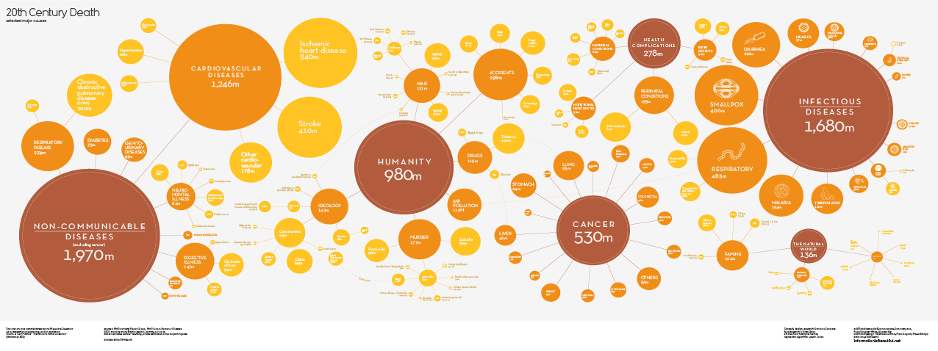

Figure 3 - 20th Century Death (2013)

In a 2001 CIA report on Long-Term Global Demographic Trends this was explained further ;
“Health issues, particularly those caused by the spread of infectious diseases, are likely to be key factors affecting population trends. Infectious diseases are a leading cause of death, accounting for a quarter to a third of the estimated 54 million deaths worldwide in 1998. Of the seven biggest killers worldwide, tuberculosis, malaria, hepatitis, and, in particular, HIV/AIDS continue to surge, with HIV/AIDS and TB likely to account for the overwhelming majority of deaths from infectious disease in developing countries by 2020. The spread of infectious diseases results from changes in human behavior—including lifestyles and land use patterns, increased trade and travel, and inappropriate use of antibiotic drugs—as well as from mutations and pathogens. These diseases are likely to aggravate and, in some cases, may even provoke economic decay, social fragmentation, and political destabilization in the hardest hit countries in the developing world whose health systems are ill-prepared to deal with them. While infectious disease rates have dropped in industrialized countries, lifestyle-induced diseases are on the rise, a major contributing factor in the number of elderly requiring costly long-term care.”
This Details the fact that Death from Disease and can be a result of the culture and society in which people live, and therefore Society’s relationship with Death from Disease can be specific to that Society. This can also be seen in Figure 4 and Figure 5 from the World Health Orgnisation which shows the 10 leading causes of death by income group (2011) comparing low and high income countries
Assessing how people die in a particular country can help organise health care provisions and avoid preventable Death. For Example despite better healthcare, numbers of people dying of Ischaemic heart disease, which can be caused by lifestyle habits, is greater in high income countries, than in low income countries.

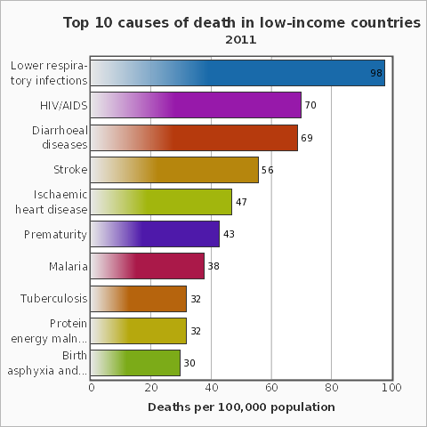 | 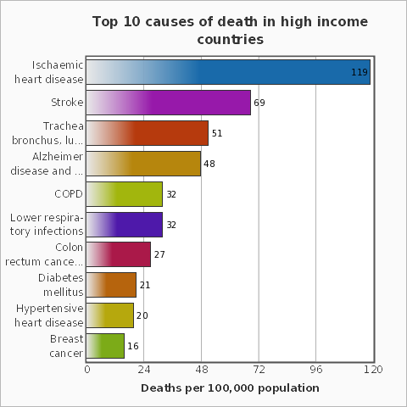
Figure 4 - The 10 leading causes of death in low income countries (2011) | Figure 5 - The 10 leading causes of death in high income countries (2011)

NHS Choices states how many Deaths occur in the UK due to Heart Disease;
“Coronary heart disease (CHD) is the UK's biggest killer, causing around 82,000 deaths each year. About one in five men and one in eight women die from the disease.”
This unpleasant Death can be avoided for many by a change in lifestyle habits, but knowing something is bad for your health and may even cause Death, may not be enough to stop you doing it. As Death is removed from our society, is it more difficult for us to imagine our own Death, especially as we are told our behaviour means it is more difficult to achieve a “Good” Death?

  - Anatomy Act
In the 18th Century the re-use of coffins, led to the discovery that not everyone had been dead when buried, the fear of being buried alive led to people holding wakes, and buying safety coffins with bells on. The fear of what could happen to your body after death was also a concern. Medical schools required bodies to study. Bodies that were supplied to the schools were of executed murderers, because of this having your body dissected after death had the stigma of a shameful death. The lack of bodies available for anatomical study led to the rise of resurrection men, or grave robbers who sold bodies to medical schools. They were also called Burkers after Burke and Hare began murdering people to have bodies to sell, for which burke was hanged in 1829. Satirical art of the time including the work of Thomas Rowlandson, describes the worries surrounding death, what would happen to your body after death, and the distrust of medical practitioners. The Anatomy Act of 1832 allowed bodies that had not been claimed by family members to be used for dissection. This was seen by some as being unfair to the poor, as most bodies came from the workhouses, and so there was a fear of dying in the workhouse and not having anyone to speak for you if you didn’t want your body donated. Today donation is more accepted but there are still people who do not like the thought of dissection, or have religious reservation. To improve the amount of organ donation The Human Transplantation Wales Bill was passed on the 2nd of July 2013. Until 2015 people will still be encouraged to opt-in as a potential donor, after 2015 people who do not want to donate will need to opt-out, this is a presumed consent or soft opt-out system. If successful this may be adopted later across the UK.
Death would have historically been something people would have seen first-hand much more frequently, with a lack of contraception, and high infant mortality as well as a lack of understanding of anatomy and medicine. With greater medical advancements people are able to survive ailments that until recently would have meant death. Death would have been seen in the home and in the community. The treatment of people within hospitals, hospices and in nursing homes, often mean that the dying person is separated from the wider community before death. It is also less common to hold a wake for the dead, with families choosing either to see the deceased, usually in a Funeral Home, or to “remember them as they were in life”.

  - NHS and Death
Death can also be approached in different ways by the individual. A good death may mean different things to different people. For some it may mean how a person is remembered after death. The ability to reach old age is available to most of the western world, made possible by improved health and nutrition, medical advancements as well as better working conditions. The ability to keep people alive for longer, has produced a society in fear of Death. The issues of Euthanasia and assisted suicide both illegal in the UK have been strongly debated. The fight to be able to have the “right to die” has most recently been taken to the High Court by locked in sufferer Tony Nicklinson, asking that a doctor carrying out a patient’s wishes to die would not be prosecuted. With technology, our understanding of our own mortality can be fixed with one question “How long?” If an illness is terminal, a patient may or may not want to know how long they have left, each option providing knowledge both positive and negatives to them. When given an approximation termed in days, months or years, Some people who know their life expectancy can see it as a chance to plan, and to be a part of the decision making process, before death, at the point of death and after death. A living will or advance directive can give doctors information although it is not legally binding on them, about how you would wish to be treated medically under certain conditions if you were unable because of those conditions to tell them yourself. Religion may also impact the treatment a patient chooses, or the Death they choose;
“Patients who are competent to make decisions will rarely choose to make life more difficult and unpleasant for themselves. However, for patients whose religion provides that murder and suicide are ultimate transgressions punishable in the next world by Divine retribution, decisions concerning end-of-life issues such as ceasing active curative treatment or withholding life-sustaining treatments cannot be based just on personal preference, best medical opinion, or the constraints of secular law.”
In an Interview with the BBC, discussing a new documentary on his life, Stephen Hawking was asked;
“ After suffering from Pneumonia you were once put on a life support machine, which your wife was given the option of switching off, should the families of those who wish to die but who are too disabled to take their own lives be able to assist them without fear of prosecution?”
His reply shows the concern for proper safeguards to ensure that enabling a right to die, would not impact on a patients right to live;
“I think those who have a terminal illness and are in great pain should have the right to choose to end their lives and those that help them, should be free from prosecution. We don’t let animals suffer, so why humans, but there must be safeguards that the person concerned genuinely wants to end their life and they are not being pressurised into it or have it done without their knowledge and consent as would have been the case with me.”
Advancements in medical knowledge mean that in the future we could all be given the chance to know when we would die of health conditions. At Lancaster University, Professors Aneta Stefanovska and Peter McClintock have been researching endothelial cells. An endotheliometer was designed as a result of their research which could measure oscillations of the inner lining of blood vessels (endothelium) to “provide new ways of assessing “cardiovascular age”, as compared to chronological age”
The Liverpool Care Pathway for the dying patient was brought in, in an attempt to “ensure that all dying patients, and their relatives and carers, receive a high standard of care in the last hours and days of their life”
In July 2013 an independent review of the Liverpool Care Pathway, recommend that it should be phased out.
“The Review panel recognised that, when applied correctly, the Liverpool Care Pathway does help patients have a dignified and pain-free death. And they support the principles underpinning it. However, they heard of too many cases where the LCP was simply being used as a ‘tick box’ exercise, its users failing to take account of a patient’s individual needs.”
The review discussed Death in the Liverpool Care Pathway;
“The introduction and widespread use of the LCP must be seen in the context of a number of developments in society itself. One of these is a substantial shift towards the idea of patient choice, with people increasingly likely to question treatment plans for themselves and their relatives, and to question the authority of clinicians. A second factor is that death and dying is now beginning to be debated more openly.
Nevertheless it seems still to be the case that, in practice, the discussion of death as an inevitable and, in some cases, imminent aspect of life is regarded as morbid and thus avoided. Even with patients suffering from terminal conditions, it is common for there to have been no discussion with patients, their consultants or GPs, relatives, and carers, about preparing for dying”
The importance of good communication when dealing with Death is stressed further;
“No matter how much effort is put into training clinicians in good communication skills, unless everyone in society – members of the public, the press, clinicians, public figures – is prepared to talk openly and honestly about dying, death and bereavement, accepting these as a normal part of life, the quality of care and the range of services for the dying, their relatives and carers will remain inconsistent. The Review panel strongly supports the work of organisations that promote public awareness of dying, death and bereavement.”
While our own Death remains a taboo, Art can provide a challenge to this.
This chapter has looked at how society’s relationship with Death has been influenced through history by Religion and Medicine. This has been done using examples in three sections, the first; Religion in early Britain to the Reformation and the return of Catholicism. The second part discussed Resurrection Men, body donation and the Anatomy Act, and the third considered the effect of the NHS on people’s relationship with Death, including debates over Euthanasia, assisted suicide, and the Liverpool Care Pathway. It has discussed ideas of a “Good Death” and a “Bad Death”, and the importance of Individual choice to those who are dying. The next chapter will focus on how we depict Death, in Art and Media, and how this has altered with the introduction of new technologies.

- Depicting Death
The previous chapter considered society's relationship with Death, using historical references to Religion, and Medicine, as well as how this relationship has changed over time, with scientific advancements. This chapter will consider how technology has influenced our depiction of Death in Art and in the Media through history which in turn has also impacted society's relationship with Death.
Previously Artists have depicted Death in terms of the personal (as with Ron Mueck’s “Dead Dad”), religious, historical, or political. It is interesting how by pushing death to the outside of society, we have increased its depiction as a clean sanitized image. The reality of Death, so frequently depicted on TV, in films, or from news programmes is removed from everyday life. With modern technology more people have phones or cameras to record with, meaning images of real world disasters are being filmed more frequently. Large disasters such as 9/11 or the 2004 tsunami have meant that videos and photographs taken by onlookers have been used by mainstream media. Frightening images of death can now be shown almost instantaneously in full colour, from every angle, played repetitively. In light of this has war Art lost its audience. Would the Art produced in the trenches of World War 2 recording the horrors of war, or Goya’s Disasters of War, have been produced in today’s society of photojournalism, documentation, and video? Francisco José de Goya y Lucientes “The Disasters of War” was seen as too controversial to be seen in his own lifetime, and was released thirty five years after his death. The Chapman brothers reinvented Goya’s artwork, returning frequently to Plate 39, Grande hazana! Con muertos! (A heroic feat! With dead men!), they produced “Great Deeds Against the Dead” which featured dismembered mannequins. It was featured in the Sensations Exhibition of 1997, the Chapman’s 3d visualisation of Grande hazana! Con muertos! came 134 years after Goya’s Disasters of War was first published and yet was still as shocking. Room 3 Violent Death, of The Richard Harris Collection, Death: A Self –Portrait was described in the catalogue;
“This room is dominated by three groups of works considered to be among the most powerful anti-war manifestoes ever made: Jacques Callot’s “The Miseries and Misfortunes of War”(1683), Goya’s “The Disasters of War” (1810-1820) and Otto Dix’s “The War” (1924). With disturbing candour, these enthralling images communicate the dehumanising effects of war, and the chaos and brutality of death on an industrial scale”.
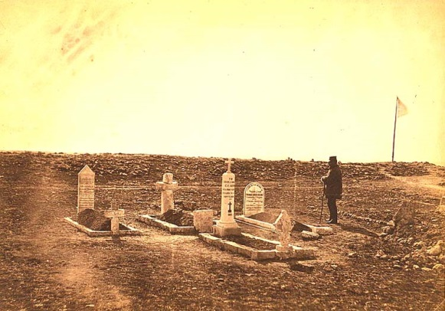
Figure 6 - Photograph by Roger Fenton , Crimean War (1855)

The first official war photographer is said to be Roger Fenton who took photographs of the Crimean War of 1855 (Figure 6). The early technology combined with a wish to show the conflict was going well, meant a lack of photos containing what we consider today to be the realities of war. The photograph of Cathcart Hill with graves of Generals is one of the few showing death. Since then images of death and dying have become much more common place.

  - Untimely Death
Images of tragedies can lead to empathy for people on the other side of the world, having more impact than words. Outrage at an “untimely” death can be something people can connect behind. The Death of the innocent from War, natural and man-made Disaster has often been used to connect people emotionally to a story, because the Death of an innocent is unfair, what did they do to deserve this? Nothing. Before knowing anything about the subject, we are able to conclude it was not their fault. Bartholomew’s image of a child buried in rubble is one such image (Figure 7).
“On the morning of Dec. 3, 1984, a pesticide plant run by Union Carbide leaked about 40 tons of deadly methyl isocyanate gas into the air of Bhopal, quickly killing about 4,000 people. Lingering effects of the poison raised the death toll to about 15,000 over the next few years, according to government estimates.
In all, at least 500,000 people were affected, the Indian government says. More than 25 years later, activists say thousands of children are born with brain damage, missing palates and twisted limbs because of their parents' exposure to the gas or water contaminated by it.”
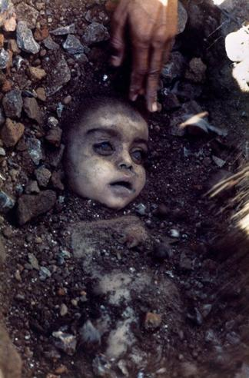
Figure 7 – Photograph by Pablo Bartholomew, Bhopal Gas Tragedy (1984)

Mark Wehrly writes about the shift to sensationalist reporting of murders in Newspapers;
“In the late nineteenth century, newspaper readers in Victorian Britain witnessed a revolutionary change in reporting characterised as a shift from the “old” to the “new journalism.” Newspapers imbued with this “new journalism” appealed to a more common, base appetite for sensational news, created by a new mass readership that grew in tandem with rising literacy levels and cheaper newspapers. Among the most significant events in the proliferation of “new journalism” were the Whitechapel Murders, which created the myth of “Jack the Ripper.”
“Media coverage of the first and second world wars or the 9/11 and7/7 terrorist attacks also constitute examples of the way journalism confronts death. But while war and mass murder are more extensive subjects in human terms, the tradition of crime reporting has been, for the past century, perhaps the most institutionalised way within the profession of journalism in which death and journalism coalesce. The way in which the human-interest value of the individualised murder story has played a seminal role in the history of journalism throughout the twentieth century has profound lessons for journalism. The role journalism has played in the way death, particularly murder, is perceived in popular culture, cannot be underestimated, and as such provides a window to public perceptions of mortality. It has frightened, but it has also fascinated - and for both those simple reasons, in spite of ethical dilemmas, it has bound column inches to the nails of coffins, in much the same ways, for over a century.”
Untimely Death can be in the form of a natural disaster, as with the exhibition at the British Museum Life and Death Pompeii and Herculaneum.
“In AD 79 Mount Vesuvius broke its centuries-long silence, with devastating results for the cities of Pompeii and Herculaneum and their inhabitants.”
The Exhibition showed not only how they lived, but how they died. Death has become Art.
“The exhibition will include casts from in and around Pompeii of some of the victims of the eruption. A family of two adults and their two children are huddled together, just as in their last moments under the stairs of their villa. The most famous of the casts on display is of a dog, fixed forever at the moment of its death as the volcano submerged the cities. “
People who were encased in Ash by the eruption had had their bodies burnt away, but the Ash had formed a mould still containing their bones. Archaeologists had chosen to fill these moulds with plaster to retain the cast instead of retrieving the bones. Recently some of these plaster figures have been scanned and forensic artists have produced busts from the scanned measurements taken from the bones.
Events such as 9-11 in 2001 and the tsunami of 2004 have also shown a large scale loss of life. The film “The Impossible”(Figure 8) based on a true story of one family’s experiences of the tsunami, although praised for its handling of a sensitive story, was criticised for allowing trailers of the movie to go into movie theatres without a warning. People who had either been through the tsunami themselves or who had family die in the tsunami and had gone to the cinema to watch something else were unprepared for it.

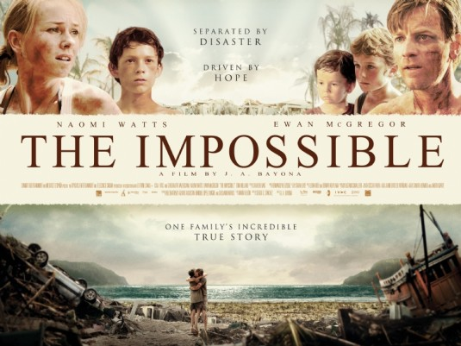
Figure 8 - Poster for “The Impossible” (2012)

This was in contrast to the constant footage at the time on news broadcasts, often where people were watching horrible scenes in the hope of finding news about a loved one, but it is the situation and the lack of choice these people felt in being confronted with images concerning death that they felt connected to. The cinema is often a place for people to confront the idea of death whilst remaining in a safe environment themselves. In his book “The Horror Film, An Introduction”, Rick Worland writes;
“The most basic fear in the horror story is the fear of death. But this is only the beginning of its impact and appeal. The fate of horror’s most unfortunate characters usually comes down to two possibilities, which a given story may or may not consider synonymous – death, the physical fact of the end of life; and damnation, a meta-physical conception that describes a state in which the immortal “soul” is condemned to eternal suffering and punishment. Creatures in horror stories, as well as their victims, often straddle these two domains in a horrible state that is neither death nor life – the threat of becoming one of the “living dead” or “undead”. The monster can be seen as the personification of Death itself which, like the traditional figure of the Grim Reaper, is an ultimately unstoppable opponent relentlessly committed to the destruction of healthy and vibrant human beings.”

  - September 11th 2001
In this section I will cover the impact of September 11th 2001 on people and on Art. Although this happened on American soil, the nature of our western communication encourages us to see this as something we are connected to and affected by. The people have not remained just a headline containing the number of dead, but individuals. This is a modern phenomenon that has grown with technology, from the newspaper, to the telephone, to radio, to television, and on to the Internet each making the outside world seem closer than ever before. (Figure 9).

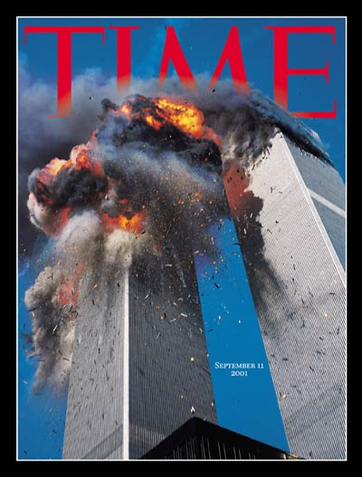
Figure 9 – Photograph by Lyle Owerko on Cover of Time Magazine, showing September 11th WTC attacks

“On September 11, 2001, nineteen al Qaeda terrorists hijacked four commercial U.S. jetliners, deliberately crashing two of the planes into the North and South Towers of the World Trade Center and a third plane into the Pentagon. After learning of the other attacks, passengers and crew members on the fourth plane attempted to commandeer control, and the plane was crashed into an empty field in Western Pennsylvania. Nearly 3,000 people were killed on that day, the single largest loss of life from a foreign attack on American soil.”
Following September 11th there was much debate about how much the American Government knew. The conspiracy theorists included famous names and suggested anything from the attacks were known about but ignored (in the same way that Group Captain F. W. Winterbotham claimed that Prime Minister Churchill ignored intelligence of the German’s plans to bomb Coventry, so as to hide the fact that the Enigma codes German’s were using had been deciphered) to the building's structure being weakened and explosives added to create a more deadly event that would allow government to call for stricter controls in the wake of peoples sorrow. There are even suggestions of Tower 7 being a controlled demolition as it fell vertically downward. This response had more in common with the Assassination of JFK than the response to the Tsunami. When it came to the tsunami it was a natural event, which could not have been stopped but led to questions about how we improve early warning detectors, and was enough done in the wake of the disaster. In the case of September 11th, the deaths were preventable and “man-made”, we saw planes flying into buildings, and asked why in a way we cannot ask of nature. It is not just that there were British people in both disasters that have connected British people with overseas disasters. We are brought closer to those situations abroad by Modern Technology and instant news. We see things live, in full colour, and can access it on demand. We no longer have to wait for news to travel around the world. Technology allows us to mourn the dead we didn’t know, whatever nationality, instantly. Social media allows us to share images and opinions.
In the wake of 9-11 those who had missing family members and friends left pictures of them around New York. The New York Times contacted the telephone numbers on these posters and started compiling details, photos and memories. Portraits of Grief, acted like an Obituary for the missing of 9-11, giving faces names and personalities to the lost;
“Three days after the attacks, reporters at The New York Times, armed with stacks of the homemade missing-persons fliers that were papering the city, began dialling the numbers on the fliers, interviewing friends and relatives of the missing and writing brief portraits, or sketches, of their lives.”
Although these were photographs of those who had died, they were photos in life, distanced from what had happened, the sketches remembered them for their life while the collection grouped them together for their death. In his book 9/11 Culture, Jeffrey Melnick describes independent on-line photography collections that appeared in the wake of 9-11 of photos taken of 9-11, some of these collections have been exhibited, toured and released as books;
“Three major photo collection sites are framed by declarations that the anthology of images is the best possible expression of the people in this moment of terror and pain. According to Here is New York, The September 11 Digital Archive, and The September 11 Photo Project, taking photographs on 9/11 is what democracy looked like. Each of these curatorial efforts also makes fairly direct claims that this is what 9/11 art looks like, and this is what the telling of 9/11 history looks like.”
These projects have validated individuals taking photographs of death, but still death itself is kept at a distance in this visual narrative. The planes crashing and the buildings collapsing, the horrified looks on the faces of those watching all points to death on a large scale, but this is death we know is happening rather than death we are seeing. When people started falling from the building, the T.V. cameras turned away, filming instead the reaction of onlookers. Photographs were taken of the falling, the most famous of these was the falling Man taken by Richard Drew, photographer at Associated Press, and it was published in newspapers on September 12th causing outrage. In the documentary “The Falling Man”, Drew says;
“I see this not as this person’s death, but as part of his life. There’s no blood, there’s no guts, it’s just a person falling.”
In the documentary, writer Tom Junod is shown following the story of the photograph;
“I talked to the coroner’s office in New York, I asked them for a count of how many people jumped that day, and what the woman at the coroner’s office said was nobody jumped that day, they were blown out, they were forced out, we don’t say that they jumped, nobody jumped.”
The documentary attempts to deal with the apparent contrast between the acceptable face of Death, in the anonymous group, and recovery from Death, in the photos of fire fighters etc., and the unacceptable in terms of seeing the individual who is about to die or has died. Jonud redefines the fallen man’s death, and talks of the similarity between the falling Man and the Unknown Soldier.
When we think of the World Trade Center Complex, we think of the twin towers and tower 7, but in their destruction the other WTC buildings were badly damaged, later to be demolished, all new towers on the site are due to be finished by 2015. The most famous memorial to 9-11 is on this site. It took ten years for the 9-11 memorial to be created, and in that time another memorial was organised nearby. (Figure 10) In the spring of 2002, 88 searchlights were shone into the sky in the outline of the twin towers from the roof of a building to the west of the site. This “tribute in light” has carried on at each anniversary of 9-11, it is sponsored by the Municipal Art Society.
“Tribute in Light is one of the most powerful and healing works of public art ever produced. The majestic blue twin beams are presented annually by MAS, shining from dusk on September 11, through dawn the next day. Visible within a sixty-mile radius on a clear night, Tribute has become a world-renowned icon of remembrance, honoring those who were lost, as well as those who worked so hard to get our city through that terrible trial.”
Although the new memorial has been finished the Tribute of light has continued thus far, shining each year on September 11th. The 9-11 memorial features the names of those who died.

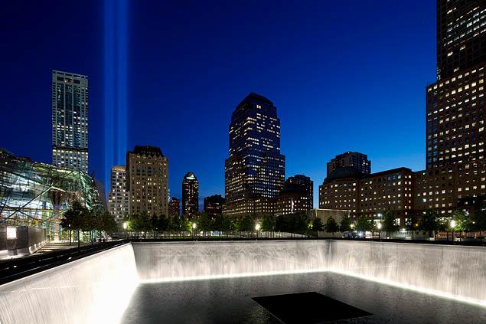
Figure 10 – Photograph by Mark Lennihan, The Tribute in Light shines above reflecting pool at 9/11 Memorial

“The Memorial’s twin reflecting pools are each nearly an acre in size and feature the largest man made waterfalls in the North America. The pools sit within the footprints where the Twin Towers once stood. Architect Michael Arad and landscape architect Peter Walker created the Memorial design selected from a global design competition that included more than 5,200 entries from 63 nations.”
Many Artworks have made in memory of 9-11, not just in New York. There are too many to discuss, so this is a comparison which displays and compares acceptable and not acceptable. In the article “Shameful Art Attack Rock Center Showcases WTC Leaper” in the New York Post, Andrea Peyser talks derogatively about Eric Fischl’s sculpture "Tumbling Woman"(Figure 11) sited at the Rockerfeller Center in 2002, the one year anniversary of 9-11.

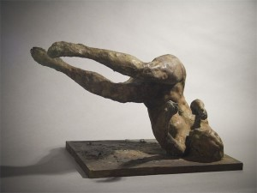
Figure 11 - Eric Fischl, "Tumbling Woman" (2001)

“A violently disturbing sculpture popped up last week in the middle of Rock Center's busy underground concourse - right in front of the ice-skating rink. It depicts a naked woman, limbs flailing, face contorted, at the exact moment her head smacks the pavement following her leap from the flaming World Trade Center.”
After Peyser’s comments, the Rockerfeller Centre removed the sculpture. In the editorial Woman on a Horse, The New York Sun argued against Peyser’s point of view;
“Within hours of Ms. Peyser's column hitting the pavement, Rockefeller Center folded and announced that it would remove the work, which otherwise would have been on display through September 23.The record will probably show that Mr. Fischl lasted longer at Rockefeller Center than Diego Rivera managed to do.”
David Rakoff interviewed Fischl for the New York Times, in “Questions for Eric Fischl, Post-9/11 Modernism”, Fischl stated;
“I wouldn't have made the sculpture differently at all. I even regret caving in to Rockefeller Center so fast and saying: ''Yeah, take it away. I don't want to hurt anybody.'' I'm sorry I didn't raise a stink over it. I hate this idea that there are some people who have a right to express their suffering and others who don't, that there are those in this hierarchy of pain who own it more than you do. It's not about necessarily witnessing first hand that makes the experience. Picasso wasn't at Guernica when it happened; Goya wasn't there on the firing line. This is what a culture looks to art for, to put image, or voice, or context to a way of rethinking, re seeing, re-experiencing.”
This is an interesting example of Art being censored because of Death. There had been a shift in what was acceptable public Art pre 9-11 and post 9-11. The sculpture Tumbling woman was not considered an acceptable memorial, and was discarded just as the photograph Falling man had been one year earlier.
The fifth anniversary saw a piece called "To The Struggle Against World Terrorism," by Zurab Tsereteli, sited in Bayonne, New Jersey. (Figure 12) Was this considered more acceptable with the obvious reference to the buildings themselves, and with the central teardrop to the emotion felt, without the figurative death of Fischl’s sculpture?

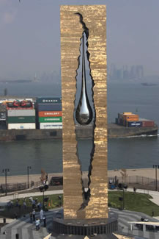
Figure 12 - To The Struggle Against World Terrorism by Zurab Tsereteli (2006)

Keynote speaker at the sculpture’s dedication ceremony was Bill Clinton who said;
“President Putin and the people of Russia have given the United States and the people of this region the great gift of solidarity in the struggle against terror. I thank my friend Zurab Tsereteli for one more time capturing the remarkable feelings that go beyond words.”
For the 10th anniversary in 2011, “Reflect” a 9/11 Memorial was produced by Heath Satow.(Figure 13) This was also the acceptable face of post 9-11 memorial sculpture. The hands are made of 3 thousand bird like shapes representing those who died, welded into two hands, holding an I-beam from the WTC. The statue in Rosemead is the other side of America from New York. In an interview with the Los Angeles Times, Satow says;
"It was really heavy creating each bird, knowing that it represented a real person. It was taking a toll — I was getting really depressed working on it."
This piece was more figurative than Tsereteli’s piece, and yet in comparison to Fischl’s work is more stylized and is a less realistic portrayal of death.
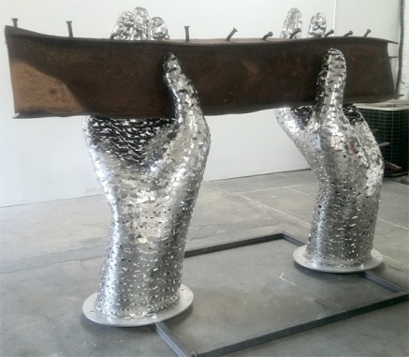
Figure 13 – Memorial by Heath Satow (2011)

The acceptable face of memorial is describing death without visualising it, the names on the memorial pools in the footprint of the twin towers, the shape of the Tribute in Light of the building not the dead but also reaching heavenwards, Tsereteli’s building shaped sculpture with a teardrop to denote grief and loss, and Satow’s use of part of the building, with the dead being symbolised as birds ready to fly away but also as a collective holding up the weight of the beam. The backlash we see to Fischl’s sculpture "Tumbling Woman" is in its reality, its use of the person as focus instead of the building. It is an image of death that is fixed and unapologetic, a statement of fact, facing death and grief and pain without the addition of a Hollywood happy ending, or phoenix rising.

  - Famous Deaths

Charles Gough was a landscape painter who died in 1805, and became more famous as the subject of many paintings and poems of the romantic style. Attachment by Edwin Landseer (Figure 14) is one such example. Gough is said to have fallen while attempting to climb Helvellyn in the Lake District, in search of an artistic viewpoint. Gough’s body was found after three months with his dog who was still alive.

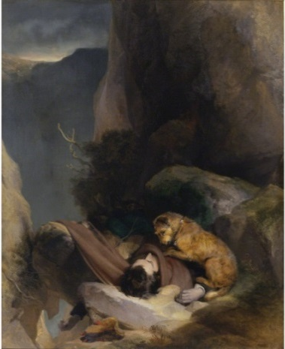
Figure 14 - Attachment by Edwin Henry Landseer (1829)

Celebrity death leads to a new phenomenon, as through television and modern media, people feel a connection with someone they don’t personally know, and may mourn their passing. Celebrity Deaths, especially unexpected death such as that of Marilyn Monroe, and Princess Diana, mean these people remain frozen in time. They have achieved Immortality after Death, never aging in a society obsessed with aging. (Figure 15)

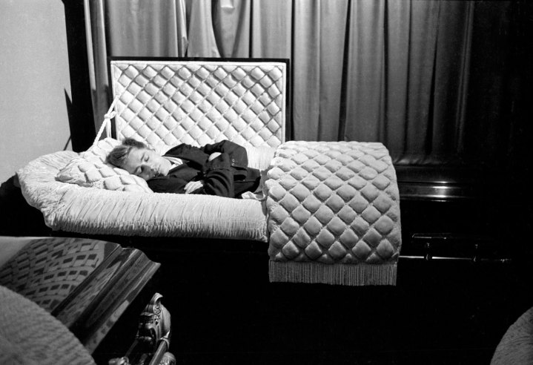
Figure 15 - Photograph by Dennis Stock (1955)

“James Dean poses in a casket in a funeral parlor in Fairmount, Indiana, in 1955, seven months before he died”.

A Charity photo campaign in 2010 featured many celebrities in caskets, (Figure 16) to advertise their digital deaths as they gave up social media until $1 million was raised for Keep a Child Alive, an HIV/AIDS charity.

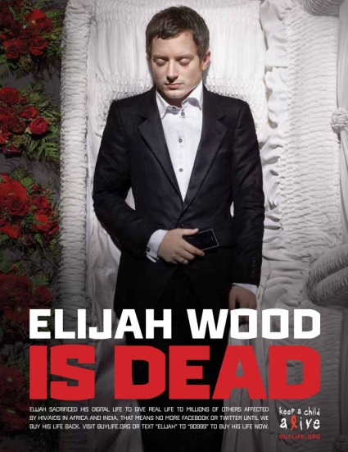
Figure 16 - Keep a Child Alive Charity Campaign Poster (2010)

“For World AIDS Day, December 1st 2010, Keep a Child Alive launched the celebrity Digital Death campaign to raise $1 million for KCA. This Digital Death involved a collective group of highly active digital artists (on Twitter/Facebook) that would sacrifice their digital lives for KCA on December 1st to force attention towards the millions of people actually dying in Africa and India. The artists and celebrities involved in the Digital Death campaign represent over 33 million Twitter followers - ironically, the same number of people currently living with HIV in the world.”

The campaign also featured stars “last tweet & testament” as they left a video message asking for their digital life to be bought back. This emphasises the difference between the stars temporary digital death which lasted from the 1st until the 6th of December in 2010, and the very real permanent death that the charity hopes to stop in Africa and India.

  - Public Death
We can compare as examples, two images of assassination. The first is the assassination of President Lincoln, by Currier & Ives, 1865. (Figure 17). The image is dramatic showing Henry Rathbone to the left of the picture pointing at John Wilkes Booth as he fires on Lincoln, and acts more as a drama than a reconstruction. Rathbone was injured attempting to stop Booth from leaving but had not seen him before the shot was fired. The second image shows the assassination of JFK 50 years ago, an image taken after both JFK and Texas Governor John Connolly had been shot, and before the shot that would hit Kennedy in the head. This still image gives a more accurate description of what happened and yet, this photo does not tell us everything. This public Death, photographed, filmed on video -the most famous by Abraham Zapruder-(Figure 18), and having many witnesses, cannot tell us decisively how it happened, or why. Indeed in the case of JFK even the number of bullets fired during the assassination has remained an issue of debate.
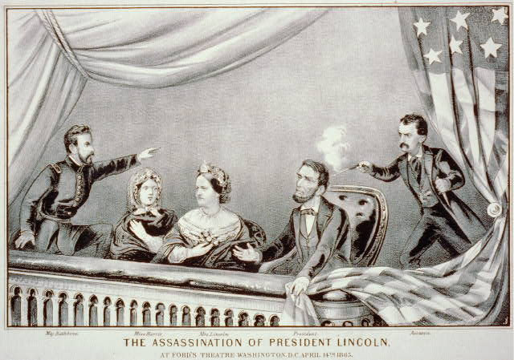 | 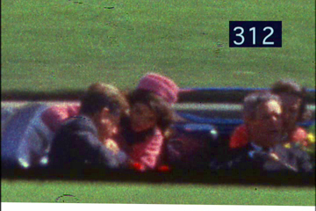
Figure 17 - The assassination of President Lincoln by Currier and Ives (1865) | Figure 18 - Frame 312 from the Zapruder film of the JFK assassination (1963)

The untimely Death, causes emotional confusion as we are not expecting it, we don’t understand it, and we have questions that are left unanswered. Celebrity Death, especially untimely Celebrity Death and even more so gory untimely celebrity death has become an area of unnerving fascination to many. Books, films, documentaries and more recently websites and forums are devoted to the subject, often featuring uncensored autopsy pictures, and some pictures without proper provenance are questioned as to their reliability from the post gunshot wound photo of Kurt Cobain, to the post car crash photo of Princess Diana. In the age of Photoshop, is this one real, has this one been altered. People discuss the how and the why of Death, using examples of suicide, Murder and Accidental Death, and the emotional connection or distance that is felt in each case. Are we living through these people’s deaths, has it become one more acceptable part of a real-life soap-opera or is this a modern day Memento Mori, a Danse Macabre, or a “there but for the grace of God, go I.”
The recent death of former Prime Minister Margaret Thatcher, although less unexpected than many sudden young celebrity deaths due to her age and illness, led to a divide in public opinion (Figure 19), between those in mourning and those holding death parties in celebration. Miners in South Yorkshire burnt an effigy of Margaret Thatcher a representation of her in Death, which they were able to treat with the anger they felt. (Figure 20). This contrasts masks busts and statues that are made commemoratively. It also acts as a performance. The song adopted by anti-Thatcherites taken from the 1939 musical “The Wizard of Oz” was “Ding Dong! The Witch Is Dead” after a campaign to get it to No.1, it peaked at No.2 in the charts.

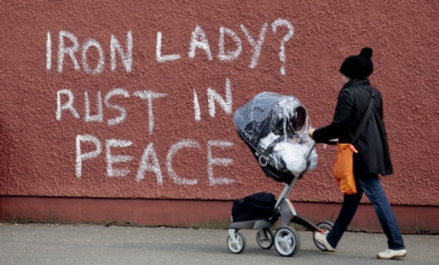 | 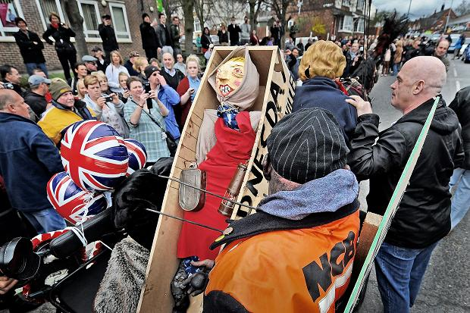
Figure 19 - Falls Road in West Belfast (2013) | Figure 20 - Effigy of Margaret Thatcher that was burnt by miners in Goldthorpe, South Yorkshire(2013)

Two days after Napoleon Bonaparte died, a death mask was made on the island of St Helena from which copies were made. One of these known as the Boys Cast [made for the Rev Richard Boys, St Helena’s Senior Chaplain] was sold for £169,250 ($260,000) at Bonhams on 19 June 2013 (Figure 21). Matthew Haley (Head of Bonhams UK Book Department) says that :

"This mask is a fascinating reflection on the nature of power and its projection. By the time the cast for the mask was made Napoleon's body had begun to decompose in the fierce heat and, as was noted at the time, his features had changed quite markedly. The very last image we have of Napoleon, therefore, is more that of a saint than the man of action and resolution carefully engineered in the portraits painted during his lifetime. "

In this case, the preservation of Napoleon’s features comes too late to be an exact copy during life, and as such becomes something else. It takes on its own life, in the same way as a statue. Mike Kelley states in playing with Dead Things: On the Uncanny//1993/2004, that

“Because of their construction in permanent materials, statues, as with the readymade, constantly evoke in viewers their own mortality. Indeed, this could be said to be the main point of Christian statuary: to rub people’s noses in their own mortality so that their minds were forever focused on the afterlife. And this is probably why, in the modern era, figurative sculpture is held in such low esteem, for this primitive fear cannot be erased from it. The aura of death surrounds statues. The origin of sculpture is said to be in the grave; the first corpse was the first statue.”

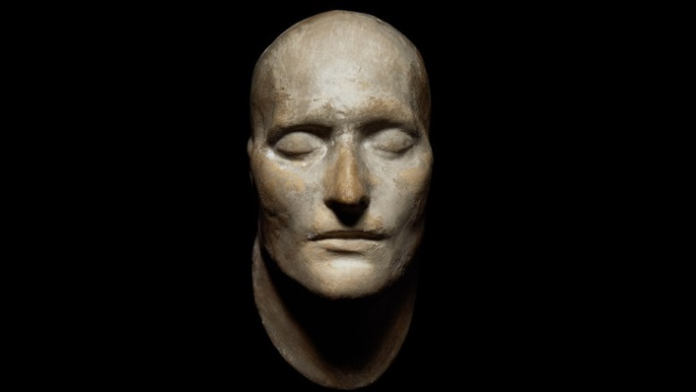
Figure 21 - Death mask of Napoleon Bonaparte (1821)

In a Bonhams press release Felix Pryor, a consultant in Bonhams Book, Map and Manuscript Department describes the importance of the Death Mask:

"Before the invention of photography, taking a cast from a person's face was the one way of producing what may be described as an objective likeness. These masks were most often taken after death. In this they became part of the funerary rites of the dead, the royal dead especially; royal death masks can be traced back to at least the time of Tutankhamun. The present death mask of Napoleon can be seen as standing at the end of this long tradition – the world's first photograph was to be taken only five years later."
Napoleon himself was known for the Expédition d’Égypte and for the 24 volumes, Description de l’Égypte published on the findings of the “savants” (artists writers scientists etc.) that accompanied the Invasion.
This chapter has discussed depicting Death and how different types of Death have been depicted. Untimely deaths are such a large grouping that this dissertation uses the second section of this chapter to explore the example of September 11th 2001 to discuss the issues surrounding this. The third and fourth sections discussed famous deaths and public deaths. This chapter considers the impact of technology not only on how death is depicted but also the way in which this impacts our relationship with Death.

- An Individual Death, Post-Mortem Choices
The last chapter considered how technology had impacted our relationship with Death, through changing media. This chapter will discuss individualisation of Death, through personal preparations and planning, as well as remembrance and choices for what happens to the body after Death.

  - Preparations
Many cultures have ways of preparing for Death. We may not be aware of these if they are outside of our personal culture or religion. By having a set idea laid out of the preparations that should ( in a personal belief ) take place, we may find Death easier to accept. If these practices are not possible this may lead to a feeling of unpreparedness, of having unfinished business or of a bad Death. If the personal belief of a good Death contains no preparations for it then there may still be comparisons to what a good Death is thought to be.
The Ars Moriendi or Art of Dying is a Christian guide to death;
“The Ars Moriendi survives in two different versions. The first is a longer treatise of six chapters that prescribes rites and prayers to be used at the time of death. The second is a brief, illustrated book that shows the dying person's struggle with temptations before attaining a good death. As Mary Catharine O'Connor argued in her book The Arts of Dying Well, the longer treatise was composed earlier and the shorter version is an abridgment that adapts and illustrates the treatise's second chapter.”
The Tibetan book of the Dead or Bardo Thodol, is a Buddhist guide to death and is in three parts; Chikhai Bardo, Chonyid Bardo, and Sidpa Bardo, dealing separately with the subjects of the moment of death, after death, and prenatal issues (prior to rebirth).
A famous quote by Tenzin Gyatso, the Dalai Lama, expands upon a positive vision of Death.
“Death is a part of all our lives. Whether we like it or not, it is bound to happen. Instead of avoiding thinking about it, it is better to understand its meaning. We all have the same body, the same human flesh, and therefore we will all die. There is a big difference, of course, between natural death and accidental death, but basically death will come sooner or later. If from the beginning your attitude is 'Yes, death is part of our lives,' then it may be easier to face.”
By allowing Death to be a part of our lives, and to discuss it openly requires a shift in society and culture, and yet as discussed in the first Chapter, society and culture have often changed its relationship with Death.

  - Victorian Post Mortem photos
Recording the likeness of a loved one or of someone famous was popular after Death, in memory of that person. In the last chapter the Death Mask of Napoleon Bonaparte was discussed. The death mask had not been the only way of recording a person’s image, and portrait painting of the dead was popular for those that could afford it, but the 1840’s 50’s and 60’s saw photography develop. Louis Jacques Mande Daguerre gave his name to the daguerreotype process, taking pictures on silver-coated copper plate. Because of the expense of the silver, photographs were luxury items. William Henry Fox Talbot introduced the calotype in 1841 using paper negatives. During the 1851 world fair at Crystal Palace, Louis Désiré Blanquart-Evrard exhibited photographs that had been chemically developed and Frederick Scott Archer exhibited photographs using glass negatives. These developments helped make photography accessible and less expensive.
The Huffington Post quotes Jane Carlyle from 1860;
"Blessed be the inventor of photography! I set him above even the inventor of chloroform! It has given more positive pleasure to poor suffering humanity than anything else that has cast up in my time or is like to -- this art by which even the poor can possess themselves of tolerable likenesses of their absent dear ones."
In “Representations of the Infamous or Anonymous Dead: Gerhard Richter’s Photopaintings and Jeffrey Silverthorne’s Photographs” Randall K. Van Schepen examines writer Siegfried Kracauer views of photography;
“Siegfried Kracauer suggests that photographs attempt to banish death by ripping a fragment out of reality in order to fix it, embalming the moment. Photography’s dialectical relationship to death becomes particularly acute, however, when the subject of the photograph is itself a dead body.”
The Dead were photographed, sometimes by themselves, or in family portraits, children often photographed with living siblings, mothers holding their dead babies. It is more heart felt when you realise how long it took to shoot early photographs, people sat unmoving for lengthy periods, which for the deceased made no difference, but for the bereaved parent or sibling must have felt like an eternity. Moving would mean blurred image, so the faces of the living were mostly expressionless, and matched the expressions of the dead. Sometimes the dead were laid out in a casket, but more frequently photographed as if still alive. Pictured as if sleeping or awake with open eyes, sometimes pupils were painted directly on to closed eyelids, or open eyes were painted on to the photographs. The dead were sat in chairs or propped up by stands that attempted to make them look as if they could stand up by themselves. In these photographs, it can be difficult to tell if a person is dead, this can be compared to the act of embalming today, where the Art lies in achieving a kind of deception that the death hasn’t occurred. Although in today’s society, most people don’t think there is anything out of the ordinary about embalming, reactions to Victorian post-mortem photos are that it was something that was done in that time and of that time. It grew out of fashion, as photography advanced to the point where people had the ability to take many photos of their loved ones when alive, and didn’t need the post-mortem photo as a remembrance. For some deaths post-mortem photos are still offered as in the cases of still-born babies. The NHS advises;
“Some parents find it helpful to create memories of their baby, for example by seeing and holding the baby and giving him or her a name. You may also like to have a photograph of your baby and keep mementos such as a lock of hair, hand and footprints, or the baby's shawl. All this can help you and your family to remember your baby as a real person and can, in time, help you come to terms with your loss”.

  - Remembrance
Death of Adults working in war and disasters is often described as they “paid the ultimate price”. This is to distinguish that they died because of what they did as in the case of the soldiers, police, fire fighters, medics or volunteers whose profession put them in danger. In this case the dead are often described as heroes who lay down their life. The 4th verse from the poem “for the fallen” by Laurence Binyon is often used in remembrance of all fallen all over the world especially for large groups of dead, and is also often followed by the additional words “Lest we Forget”.

“They shall grow not old, as we that are left grow old:
Age shall not weary them, nor the years condemn.
At the going down of the sun and in the morning,
We will remember them.”
Yet this verse hints at death in a way the first verse does not, which states;
“England mourns for her dead across the sea”.

This is the adoption of remembrance for a specific people becoming more generalised as we share a communal grief. Veterans UK, the Service Personnel and Veterans Agency, explains;
“It is a fundamental characteristic of human nature to remember and commemorate the fallen, not merely for the sake of our own peace of mind, but for the instruction of future generations that they might recognise the price of freedom. Of course what we choose to remember, defines us both individually and collectively. Remembrance functions on a number of levels, some deeply personal. It will mean different things to the comrade, the spouse, family, friends, children and grandchildren, - not forgetting the ordinary member of the wider society paying homage to the sacrifice of the fallen. Correspondingly, as the generations that fought our two World Wars pass, the oral tradition that connects us to these events fades by degrees and the duty of remembrance devolves to those of us who thankfully have not known war.”
They explain not only the need for individual remembrance, but also of a collective remembrance which teaches us of our History and about how the Death of people we might not have known personally still impacts on us. We can see examples of this at war memorials, on Remembrance Day and has also been seen when the bodies of soldiers have been repatriated to the UK through RAF Lyneham, and hundreds of people lined the streets of Wootton Bassett to pay their respects between April 2007 and August 2011. This coming together of people in a performance of respect and remembrance became a ritual that could be discussed in terms of performance art.
The physical act of mourning is often related to the fashion of mourning clothes which are often, but not always black. Wearing mourning clothes occurs less frequently in Britain today, than in other countries, as people have their own way of expressing their grief, although black is still usually worn to a funeral . Queen Victoria’s mourning for her husband Prince Albert is probably the most well-known example due to her extended 40 year period of mourning.
By looking at the way in which people wish to be remembered after Death, we see that recently a more personal approach has been adopted by many but that there are restrictions to what people are allowed to do in church grounds, so more elaborate choices are often made outside of church burials. The most famous example is the grave of Spike Milligan (Figure 22) that reads I told you I was ill, but written in Gaelic, Dúirt mé leat go raibh mé breoite “in order for it to be approved by the Chichester Diocese”.

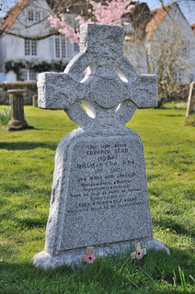
Figure 22 - Gravestone of Spike Milligan (2004)

Earthcam.com features a live stream of Andy Warhol’s grave, marking what would have been his 85th birthday. Viewers can interact with the grave;
“with live streaming video infrared and high-definition 16 images. Online visitors will be given a real life “pop art” experience with Warholian image effects and color pallets integrated into snapshots of the gravesite, each photo creating truly unique webcam art” . . .“To honor Andy Warhol’s hometown of Pittsburgh, EarthCam is giving back through a donation to The Greater Pittsburgh Food Bank. The public can remember Andy by choosing to have a Campbell’s Soup can – a signature image from Andy’s career – or a bouquet of flowers delivered to his gravesite. With the live streaming webcam, people can then watch the delivery and see their can and/or flowers at the grave.”
This action allows people to feel that they are taking part in the Art of Warhol, by using symbols from his work, and yet coming so long after his death in 1987, the technology that is used is post Warhol. The Artist has become the Art. Warhol himself said;
“Death? I don’t believe in it, because you’re not around to know that it’s happened.”
The decisions people make or that others make for them, have become more varied as individualism becomes a part of death. The personality of the deceased becomes more important and not just a decision of what the family can afford. People can make creative choices about the service itself including music poetry etc., the way their body is disposed of, or the memorial left. More websites have recently been produced from ComparetheCoffin.com where you can buy a coffin, make a plan for your funeral and get quotes for it from local funeral directors, to Finalfling.com which describes itself as a “one-stop-shop for end of life planning” and goodfuneralguide.co.uk which attempts to set out straight forward non biased advice. Other sites such as ageuk.org.uk offer advice on end of life and dealing with death.
After the death of his own child, Julian Stair was left considering the choices they had made for his burial. Stair decided later that he would have preferred to have made a more personal casket for his child. This led him to create a range of vessels he exhibited in the National Museum of Wales called, Quietus: The Vessel, Death and the Human Body.
"In all cultures around the world, pots, almost universally, have been made to hold the body in death, in both burial and cremation. They are vessels and the body itself is also seen as a vessel, a physical container for the soul or spirit."
Stair says of Quietus;
“I hope that people’s response to the exhibition will be quite varied. On one hand I hope that they’ll be interested in these as objects, as works of Art. I also hope that maybe they’ll start to think about the bigger issues of life and death. I think art has a role to play in terms of raising questions and raising issues and making us think afresh about our lives. People have ended up in my funerary jars and when that happens it’s very touching and I have been commissioned to make funerary jars for people who’ve already died but I’ve also been commissioned to make funerary jars for people who are alive.”
Head of Applied Art at the National Museum Wales Andrew Renton said of the exhibition;
“Quietus is a spectacular and ground-breaking exhibition, as well as a deeply moving and personal one. There is an age-old relationship between pottery and human burial rituals, and at National Museum Cardiff we use the archaeology collection to make connections between Julian Stair’s work and pottery used in burials by the people of ancient Wales.”

  - Alternative endings
For many, being buried is not for them. Walt Disney is often referred to as having been cryogenically suspended, in fact this is an urban myth and he was cremated. Another belief is that Disney resorts often have problems with family members bringing their deceased’s cremated ashes to the parks and covertly scattering them on rides. This is not allowed by Disney and anyone who requests it is politely denied, but as the number of cremations in America rise, the number of people who are asking for this has also increased.
Albert Einstein said: “I want to be cremated so people won’t come to worship at my bones”
Although his brain was kept for scientific study (Figure 23), it remained in an individual’s possession without studies being undertaken for four decades. This calls into question what hopes we have for our bodies after our death, whether this occurs, and the debate on if it matters. If we are dead and not there then we wouldn’t know any different, so is it only important to those we leave behind, or is it an important part of a “good death” to plan what happens to our body after we are dead.

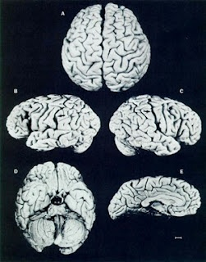
Figure 23 - Einstein’s Brain

As in America, in the UK the restrictions on scattering ashes are that if it is on private land then the land owner’s permission needs to be given. Large amounts of ashes being scattered in the same spot can affect the soil alkalinity. We are no longer restricted to the two choices of being buried in a coffin, or cremated. Deceased have been turned into carbon from diamonds to pencils, fired into space in rockets or fireworks, planted with seedlings, buried at sea as a body or as cremated remains in a reef ball, and even frozen using cryonics. Although, The Alcor Life Extension Foundation states:
“Cryonics is an attempt to preserve and protect the gift of human life. The purpose of cryonics is to maintain life, not reverse death. Lack of legal status as a person does not imply lack of moral status as a person. The spiritual status of cryonics patients is the same as frozen human embryos, or unconscious medical patients.”
This is another reason that a person’s belief may alter their connection with or view of death, and the choices they make towards the end of life, as science is used not only to prolong life, but to offer hope of an escape from death. Neurocryopreservation preserves only the head, both of these techniques rely on the science of the future advancing far enough that it can undo damage done to the body by illness, by being legally dead and what that means to the state of the body and brain, by the cryonic process itself and [in the case of neurocryopreservation] the fact that the head has been removed from the body. This has led to questions about what they are trying to preserve. The fact that cryonic centres accept that there are no guarantees and that it relies on future technology means that although no human could be successfully revived now, it is difficult to say it would never be possible, however unlikely.
This has meant science fiction stories in books, on TV or in films, have often used cryonics as a basis for “health travel” space travel or time travel. As featured in Futurama, this device allows an animated series set in the future to contain cultural references from our time, both from the main character Fry, who finds himself “transported” into the future after falling into a cryonic chamber, and the many guest stars that feature as heads in jars (Figure 24).

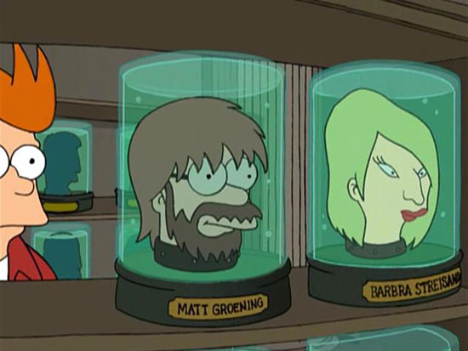
Figure 24 – Matt Groening, Still of Futurama, animated TV series

Another way in which Death has been discussed in Science Fiction stories was featured in Torchwood: Miracle Day. This series, in which people no longer die, considered the implications of an increasing global population, followed by food and medical supply shortages.
We have not always reached for science to cure us. In “Playing with the Dead Thing: On the Uncanny//1993/2004” Mike Kelley states:
“Votive sculpture, ranging from life size wax figures to small depictions of afflicted body parts that a person wants healed, could be said symbolically to represent devotees themselves as sacrificial offerings to the Gods. Although these replacements are sometimes highly charged emotionally, and this throwaway quality is repressed, they still have one foot in the garbage dump. In the fourteenth century it was not uncommon for the wealthy to have a life-size, wax votive image of themselves set up in a church perpetually to mourn a loved one or to show reverence to a religious image. Churches became so overcrowded with these figures that they had to be hung from the rafters. Of course, this trash-heap of simulated devotees was eventually just tossed out”.

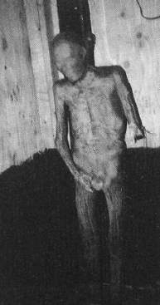
Figure 25 - Photograph of Elmer McCurdy

Elmer McCurdy (Figure 25) was found during an episode of the six million dollar man called the Carnival of spies, being filmed at the Nu-Pike amusement park in long beach California, on the “Laff in the dark” ride. His body, hanging with a noose around its neck was painted day glow orange. It was discovered this was a mummified body and not just a dummy when one of the crew, Chris Haynes, checking to see if it was made of papier-mâché pulled off an arm, and saw bone inside. Elmer had been a failed outlaw, was shot and killed by a sheriff, and became a carnival attraction as the Oklahoma Outlaw before ending up at the amusement park.
Choice and individuality is important to people in Death, and even after Death, and yet the fact that you are “not there” to oversee that your choices are being adhered to may mean that people are less likely to get what they want or even ask for it in the first place. People may also be worried about making outlandish requests if they think they will not be approved of by family, friends, or the larger community. By not researching the possibilities they might not be aware of the choice available.

  - Embalming
A common practice before burial is Embalming. This slows the rate of decay and preserves the body temporarily to allow for viewings and for time to pass between death and burial, and yet it has become so commonplace that we do not question it. While the embalming process itself in conjunction with dressing the dead (clothes, hair, make-up) has the power to remove signs of the cause of death. Embalming provides those who view the dead with a last view of their loved one which may be a better last memory than the one they had, especially if the death was painful or traumatic. This may allow family members or friends to reconnect the image of the dead with a happier time or better memories.
Catherine Davies explores the role of the media, especially in the reporting of Celebrity Death after they have aged past their most popular.
“The death of a famous ﬁgure offers an opportunity for the media to play a signiﬁcant role in a memorialising process that reassess the life of the star by highlighting features that have contributed to the image over time. This procedure generates a reinterpretation through reﬂection highlighting predominant features pertaining to the star persona that will encapsulate the star’s media presence in death”
Davies considers how the media influence over the image of dead celebrity is similar to the processes of Embalming, or a “technological taxidermy”.
“It is evident therefore that whilst there are some examples that disprove the aesthetic displacement of death’s features in the representation of celebrity death, more often than not, a restoration of the living face at its most aesthetically pleasing is apparent.
The process of technological taxidermy permits the visibility of the deceased star within visual culture but only by foregrounding their recognisable ‘lifelike’ image. This process enables the reconfiguration of the star persona by erasing associations of the dead body. Through this visual taxidermy, the star is able to transcend the mortal self and become resurrected in a media afterlife, forever preserved within the realms of the ‘extraordinary’ immortal icon.”
This can be compared to the role embalming plays in reality, as signs of death, decay and illness are removed. The dead are left with the look of peacefulness, serenity and health as if sleeping. In the media a more youthful, popular version is shown distanced from the dead, the ill, or the older version of themselves.
This Chapter has considered the many issues surrounding our personal connection and individualisation of Death. It has considered how we prepare for Death in different ways and want to be remembered as an individual, from gravestones to photographs, and how Julian Stair’s belief that the coffin for his son lacked individuality, inspired Quietus. It has also discussed how we plan for what will happen to our body after our Death and whether this can be or will be achieved. It has discussed issues of cryonics and how belief in future medical advancements has led to a belief by some in an escape from Death. It has also looked at embalming and how this process removes signs of Death and how that refusal to visually confront Death has been compared to the media’s portrayal of celebrities after Death. The next chapter will discuss how society’s relationship with Death has impacted our relationship with Art, contrasting art restoration with temporary Art installation.

- Death in Art
The previous chapter discussed society’s wish to individualise Death, through remembrance of the individual in life, creating distance from the Death itself. It viewed how planning for what will happen to the body after Death can be meaningful as it stresses the individual even more, and who they were in life. It also discussed how embalming of bodies after Death can be compared to the Media’s Embalming of celebrity identity after Death. This chapter will consider society’s unwillingness to let Art die and how that connects with society's relationship with Death . Art is preserved. Art is saved. Why? Why is Death a subject some Artists return to again and again for inspiration? This chapter will focus on the need to keep Art “alive” and how this affects the message of Art that discusses Death, when the artwork itself is refused Death. This can be compared to the use of photography and film which allow temporary Art to be recorded, so that long after a piece of work has gone, there is still a record of it.

  - Embalming Art
In An Interview, Hans Ulrich Obrist and Damien Hirst 2007 (in connection with the exhibition 'In the darkest hour there may be light. Works from the Damien Hirst murderme collection' at Serpentine Gallery, London) discussed art having its own lifespan.
Damien Hirst :
“. . . When you’re making an artwork, there’s an idea and you play around with it and then it comes to life. But you can have an idea and put things together, and then it doesn’t work. So I suppose if things can come to life then they can also die. You can create an artwork, and it comes to life, but then maybe 500 years later it dies. I’ve never really thought about that. It’s a weird thought; a good thought.”
Hans Ulrich Obrist:
“A limited lifespan? Like buildings.”
Damien Hirst:
“Yes, like everything else. In my mind I think that art’s immortal, but maybe it has a limited lifespan. All these Old Masters are falling apart, and we’re clinging onto them through preservation. It’s like in that film of HG Wells’ 'The Time Machine', when the books fall apart in his hands. You’ll get that happening with art, I guess. With a Jackson Pollock painting that’s going to happen eventually. Or is it? You can create it digitally. Maybe art is like true love; maybe it never dies. That’s my hope, anyway. But it will die with the world. If we do nothing, the earth is going to smash into the sun, so we’re fucked really.”
We are unwilling to let Art die. In war time Art is preserved, sometimes respected more than human life. In Britain Artworks were removed from museums and stored in country houses, to reduce the risk of losing art from bombing raids. The owners of these country houses benefited from not having to take in evacuees but started demanding rents, and so the artworks were stored underground in caves instead. Winston Churchill said;
“Hide them in caves and cellars, but not one picture shall leave this island”.
We have given life to these lifeless objects, and hope to preserve them. When an artwork itself is about death and mortality, and yet can be kept alive through modern preservation techniques does it mirror our own struggle with death? Is it conflicting against or merely emphasising the message that life is not permanent. The preservation of Art mirrors the embalming of the dead body. When Art is not given the respect that it is widely considered it should have, there can be a backlash. An example of this is the Chapman Brothers “Insult to Injury”;
“ . . . . Insult to Injury 2004, for which the brothers bought a series of The Disasters of War for £25,000 – printed in 1937 from original plates – and systematically defaced it, adding the heads of Mickey Mouse and grinning clowns to the figures, covering Goya with a graffiti of gas masks, bug eyes, insect antennae and the ubiquitous swastika. (They later created a similar work using Goya’s Los Caprichos series, called Injury to Insult to Injury.) The Chapmans were condemned in some corners of the press for this act of vandalism. They answered their critics with the ‘canonical defence’, this time citing Robert Rauschenberg’s Erased de Kooning Drawing of 1953, for which the artist asked de Kooning to donate a valuable drawing so that he could create a new work by erasing it, to justify their attempt to eclipse Goya.”
In “The Temples at Burning Man”, Lori Van Meter discusses how the principles that are behind the burning man festival have developed a different approach to the Art made and exhibited there;
“These principles have fostered, among other trends, a flourishing art scene in Black Rock City. Professional and amateur artists from around the world carry ponderous quantities of materials to this city where they cannot sell their work, and where most of them will burn whatever they create there. Though select pieces will escape the flames to be permanently installed elsewhere, most of the art exhibited at Burning Man is forever inaccessible to the default world. This purposeful destruction of significant contemporary art is anathema to collectors, since their approach is rooted in holding on to all things valuable. However, the Burning Man approach is rooted in letting go.”
Many art works especially art installations that have a temporary life span can be considered to have a relevance to Death not only because of their subject matter but also because of their temporary nature. Artworks may decompose, melt, collapse, return to nature, or are made up of pieces that the public are asked to remove - destroying the whole. Can we agree that all good Art is about Death. This is a personal statement by Damien Hirst that goes to the heart of what is Art. Is it more important for us to feel a personal connection to art? Issues of life and death are universal and so we can all connect to these artworks through our own relationship to Death, influenced as it may be by the society we live in. This may mean that work dealing with deeper meanings may have more impact than a purely decorative piece, but it is the individual who will bring their own views and biases in judging the work. These views will in turn be shaped by the society’s culture, history, and religion. By producing works of art that feed into these issues, artists are following a rich history that will affect how people view their own work. The Skull has remained an Iconic Image in Art throughout history, but while its use may be varied, the response to it is often more straightforward; “dark, grizzly, macabre”. While the skull itself is a vessel protecting our brain, and preserving life, the fact that we do not see the skull through life, leads us often to use the skull in reference to death or mortality. In contrast the heart which we also do not see, by pumping blood around our bodies has come to mean life or in many cases love (which may have its origins in religious references). There are many internal parts of the body which would not be seen by most during life that have not come to symbolise death as the skull has, yet it is one of the most permanent, and recognisably human. We recognise the image of a skull as a human, but one that is no longer alive. We cannot say a skull is just a skull when it carries meaning and symbolism that the viewer will bring to it whether consciously or unconsciously. By having a better understanding of this, the artist can have a better understanding of how people may react to a piece of work. Or by knowing, can choose to evoke, or challenge these reactions. As Damien Hirst explains;
“It’s every artist’s main theme...There isn’t really anything else. It just depends how far you stand back from it. Since I was a child, death is definitely something that I think about every day. But I think that everybody does. You try and avoid it, but it’s such a big thing that you can’t.”
“That’s the difference between art and life. You can frighten people with death or an idea of their own mortality, or it can actually give them vigour, and they can go away and appreciate their lives more. I’m going to teach my children how to find the good things in life without being afraid of the finality of it.”
Photographer Rankin has explored Death by taking portraits of individuals who have faced Death, from people who are fighting terminal illnesses or have survived Death in his exhibition ALIVE: In The Face of Death. Rankin states;
“Following the death of my parents six years ago I have had a strange relationship with death; only recently did it dawn on me quite how scared I am of it. I really wanted to challenge myself to confront these fears through ALIVE and document that journey.”
Images of Death and Dead Bodies have often been represented in Galleries; in paintings, photographs, video, sculpture, and performance. In “Heaven and Earth” Bill Voila, uses a video of his newborn son facing a video of Voila’s dying mother. This connection between life and death is shown as a conversation. In April 2008, artist Gregor Schneider caused controversy when being interviewed by Art Newspaper. Schneider expressed a desire to exhibit a dead or dying person as part of a gallery exhibition. Art Critic Brian Sewell was quoted in the Independent as saying ;
"Schneider's idea is part of a new examination of death, following on from Günther von Hagens, which has popularised the macabre and bizarre. There is no doubt that the photographs at the Wellcome are based on sculpture, however. People say that death is the last taboo, and we talk about it in euphemism. It has very long roots in art, but is not as celebrated as the examination of beauty or youth.” “Can such a disquieting thing be art? Should it, indeed, be done in a civilised society? Perhaps so."
Rankin, Voila, Schneider and Von Hagens, express that this desire to explore and exhibit Death is not an attempt to shock, but to examine Death as something less foreign to us. Artists have asked questions of death that society is sometimes afraid of, or uncomfortable with.
This chapter has looked at Artists such as Damien Hirst working with the subject of Death, or using Death as a major influence in their work. It has also looked at our connection with Art and its preservation, and restoration. It has suggested that our unwillingness to let Art have its own life span can be compared to society’s relationship with Death or our own fight against Death. It has considered Temporary Art Installations memorialised in film and photographs. It has also looked at Burning Man where work is created and destroyed on the same site in the spirit of letting go, with no recorded image.
- Conclusion

This dissertation has looked at how our relationship with Death is not something that is fixed. Our History, Religion, Science and Technology have all impacted how we view Death, and Art has been involved throughout history in recording our changing view of Death , as well as questioning these views and challenging them. Art can act as the introduction to a conversation about Death, that may otherwise not be initiated. “Matters of Life and Death” at Somerset House is a symposium that uses the exhibition “Quietus: The Vessel, Death and the Human Body” by Julian Stair as its conversation initiator. As with Stair, we can draw from the history that has gone before, and combine it with our own experience.
In connection to my own ceramic practice, life and death remains a consistent narrative, and with the knowledge of how our own culture influences our understanding of Death, I am able to use my work to ask questions of the viewer which may begin a conversation. This may ask the viewer to question their own views and how they arrived at them, as have the works featured in this dissertation.
I have discovered that figurative work which deals with the subject of Death is often met with criticism because of its closeness to reality, which may upset the viewer, while symbolic work can talk of Death in a way that may be more acceptable. Acceptable figurative art that discusses Death looks to the positive, such as statues of war heroes, or of Gods, styled heroically. To approach Death with realism is to court controversy. We have distanced ourselves from the reality of Death in our own lives, and Public Art is a reflection of this as seen with the reaction to Eric Fischl’s "Tumbling Woman". Gallery Art has pushed the boundaries of what is acceptable, and so context is important to how artwork is judged. In a gallery setting a viewer can be forewarned that a piece may shock, whereas in a Public space this forewarning is less achievable. In the Sensations Exhibition, viewers were forewarned, but this was used as a way of increasing the hype around the exhibition. It was protested by people who felt strongly against the works, and the publicity from this made many more people aware of the works than if it had not been commented on.
A work that deals with the subject of Death will draw not only on the History of Death in Art, but also on the history of Death in our society. Through understanding how History, Religion, Science and Technology have impacted our relationship with Death, it can give a better understanding as to how the work will be viewed. Although, as with any narrative work, it is important to understand that an individual’s viewpoint may be shaped not only by their own culture, but also by their own experiences, especially in a society that doesn’t discuss Death openly.
In Hamlet, Shakespeare described death as “the undiscovered country from whose bourn no traveller returns”. The Undiscovered Country was used as the Title of the film Star Trek VI, and was quoted by the character Chancellor Gorkon. Although Gorkon’s undiscovered country was the future, it was also Death as Hamlet saw it. For Gorkon Change is about Death of the life he knows.
GORKON: “ I give you a toast: the undiscovered country . . . the future.”
ALL: "the undiscovered country."
SPOCK: “ HAMLET, act three, scene one”.
GORKON: “ You have never experienced Shakespeare until you have read him in the original Klingon.”
In this way established Art can be re-interpreted. By looking at Art from the past we not only see how that Art deals with the subject of Death from the viewpoint of its creation, we can also add our own bias, and re-invention of the subject matter.
As symbols can be used to represent Death, so too can Death be used as symbolism for change. Death can then be seen as a wider category in Art. We may see issues of Death in work where It was never intended, or it may not be visible to us in works where the initial inspiration for its creation was Death.
Andres Serrano’s The Morgue (1992), a collection of close up photographs of dead bodies is the reality of Death, but a very specific type of death. We may find this series upsetting due to the nature of the photographs recording the “Bad Death”, whilst Bill Viola’s work Heaven and Earth compares the Birth of his son with the Death of his mother, which is suggestive of the circle of Life and Death. The assumption that Art can show that Death is a natural event that follows life , is only relevant to work that discusses the “Good Death”. Again, the reality of the “Bad Death” is disconcerting as the viewer place themselves in a position of empathy.This is not the Death they would choose for themselves or for another. I believe it is important that Art uses the subject matter of both the “Good Death” and the “Bad Death”, as to ignore one is to refute its existence which in turn relates to our own relationship with Death, and our unwillingness to converse about Death.
This dissertation asked, “Does the depiction of Death in Art, mirror modern society’s relationship with death?” I have learned that Artists have used their work to discuss their own relationship with Death or the relationship that society has with Death at that time, throughout Art History, they are able to question society’s relationship with Death. Artists can be curbed by what is seen as acceptable in society, but they can also debate what is acceptable and push boundaries to extend what is possible. Death in Art does not only mirror modern society’s relationship with Death, it also can influence and change it, by starting a conversation. This dissertation has led me to understand that as a ceramic artist, but also as an individual in this society, I am part of this conversation.

- References

9/11 Memorial Timeline, (2013). 9/11 Interactive Timelines. [Online]
Available at: http://timeline.911memorial.org/#FrontPage [Accessed August 2013].
9/11 Monument, (2013). President Clinton's Speech as delivered at the Dedication Ceremony: September 11 2006 - To The Struggle Against World Terrorism by Zurab Tsereteli. [Online] Available at: http://www.911monument.com/presidentClintonSpeech.cfm [Accessed August 2013].
Adams, T., (2013). Sam Parnia - the man who could bring you back from the dead. [Online] Available at: http://www.theguardian.com/society/2013/apr/06/sam-parnia-resurrection-lazarus-effect [Accessed 16 August 2013].
Advameg, Encyclopedia of Death and Dying, (2013). Ars Moriendi - body, life, history, beliefs, time, person, Fifteenth-Century Beginnings. [Online]
Available at: http://www.deathreference.com/A-Bi/Ars-Moriendi.html
[Accessed August 2013].
AFP/ Getty Images, 2013. Photograph of Effigy of Margaret Thatcher that was burnt by miners in Goldthorpe, South Yorkshire. [Online]
Available at: http://www.thetimes.co.uk/tto/news/uk/article3741992.ece
[Accessed August 2013].
Alcor Life Extension Foundation, (2013). Cryonics: Alcor Life Extension Foundation. [Online] Available at: http://www.alcor.org/ [Accessed August 2013].
Annenberg Foundation, (2013). Art Through Time: A Global View - Death. [Online]
Available at: http://www.learner.org/courses/globalart/theme/6/ [Accessed 16 August 2013].
Aries, P., (1985). Images of man and death. Cambridge Mass: Harvard University Press.
artdaily, (2013). Alive: In the Face of Death - Rankin installation and exhibition at the Walker Art Gallery. [Online] Available at: http://artdaily.com/news/62657/Alive--In-The-Face-of-Death---Rankin-installation-and-exhibition-at-the-Walker-Art-Gallery#.UjSBxMasiSo [Accessed August 2013].
artlyst, (2013). Andy Warhol Live Graveside Webcam Honours Artist's 85th Birthday. [Online] Available at: http://www.artlyst.com/articles/andy-warhol-live-graveside-webcam-honours-artists-85th-birthday [Accessed August 2013].
Autopsy: Life and Death, Dr Gunther von Hagens, Professor John Lee. (2006). [Film] Germany: Channel 4.
Bartholomew, P., 1984. Bhopal Gas Tragedy. [Online] Available at: http://www.nbcnews.com/id/37551856/ns/world_news-south_and_central_asia/#.UqXUrvS-25o [Accessed August 2013].
BBC News, (2004). Milligan gets last laugh on grave. [Online]
Available at: http://news.bbc.co.uk/1/hi/england/southern_counties/3742443.stm
[Accessed August 2013].
BBC News, (2013). Stephen Hawking on death, disability and humour. [Online]
Available at: http://www.bbc.co.uk/news/science-environment-24120574
[Accessed 17 September 2013].
Bonhams Auctioneers, (2013). Death Mask of Napoleon makes £170,000 at Bonhams. (1821) [Online]
Available at: http://www.bonhams.com/press_release/13967/
[Accessed August 2013].
Bronfen, E., (1992). Over her dead body: death, femininity and the aesthetic. Manchester: Manchester University Press.
Channel 5, (2013). Train Station, World's Busiest, Channel 5. [Online]
Available at: http://www.channel5.com/shows/worlds-busiest/episodes/train-station
[Accessed 9 August 2013].
CIA, (2001). Long-Term Global Demographic Trends: Reshaping the Geopolitical Landscape. [Online] Available at: https://www.cia.gov/library/reports/general-reports-1/Demo_Trends_For_Web.pdf [Accessed August 2013].
Currier & Ives, 1865. "The assassination of President Lincoln". [Online]
Available at: http://www.loc.gov/pictures/resource/cph.3b49830/ [Accessed August 2013].
Danchev, A., (2011). On art and war and terror. Edinburgh: Edinburgh University Press.
Davies, C., (2012). No Mere Mortal? Re-materialising Michael Jackson in death. Celebrity Studies, 3(2), pp. 183-196.
Davies, C., (2013). Journal: Mortality, Technological Taxidermy : Recognisable faces in celebrity deaths , manuscript CMRT-2009-0013.R2, s.l.: s.n.
Dollimore, J., (1999). Death, desire and loss in Western culture. London: Penguin.
Earthcam, (2013). The Warhol Cams. [Online] Available at: http://www.earthcam.com/usa/pennsylvania/pittsburgh/warhol/index.php?cam=warhol_figmentstream [Accessed August 2013].
Edwards, C. et al, (2013). Mortality, Dying and Death: Global Interdisciplinary Perspectives | Caroline Edwards. [Online] Available at: http://www.academia.edu/193248/Mortality_Dying_and_Death_Global_Interdisciplinary_Perspectives [Accessed 16 August 2013].
Farnsworth, T., (2010). Margaret Thatcher does the Dead Parrot Sketch - YouTube. [Online] Available at: http://www.youtube.com/watch?v=DQ6TgaPJcR0 [Accessed 16 August 2013].
Fenton, R., 1855. Photograph of Crimean War. [Online] Available at: http://www.allworldwars.com/Crimean-War-Photographs-by-Roger-Fenton-1855.html [Accessed August 2013].
Fischl, E., 2001. Tumbling Woman. [Online] Available at: http://oneartworld.com/artists/E/Eric+Fischl.html?atab=works&image=39793
[Accessed August 2013].
Gorer, G., (1965). Death grief and mourning in contemporary Britain. s.l.:Cresset Press.
gov.uk, (2012). Brain Death - NHS Choices. [Online] Available at: http://www.nhs.uk/Conditions/Brain-death/Pages/Introduction.aspx [Accessed August 2013].
gov.uk, (2012). Coronary heart disease (Ischaemic heart disease) - NHS Choices. [Online] Available at: http://www.nhs.uk/Conditions/Coronary-heart-disease/Pages/Introduction.aspx [Accessed August 2013].
gov.uk, (2013). Coping with stillbirth - Pregnancy and baby guide - NHS Choices. [Online] Available at: http://www.nhs.uk/conditions/pregnancy-and-baby/pages/coping-with-stillbirth.aspx [Accessed August 2013].
gov.uk, (2013). Liverpool Care Pathway review panel press release. [Online]
Available at: https://www.gov.uk/government/uploads/system/uploads/attachment_data/file/212452/Press_notice_-_Liverpool_Care_Pathway.pdf [Accessed August 2013].
Gregory, S., (2003) Skulduggery (2003). [Online] Available at: http://www.bridgemaneducation.com.ezproxy.uwic.ac.uk/ImageView.aspx?result=44&balid=265100 [Accessed August 2013].
Griffiths, S. & Riley, J., (2013). Daily Mail, Science. Scientists solve mystery of bone-jumbled medieval crypt: Chapel containing hundreds of skeletons was a place of pilgrimage. [Online] Available at: http://www.dailymail.co.uk/sciencetech/article-2391375/Holy-Trinity-Church-Rothwell-Chapel-contains-hundreds-skeletons.html
[Accessed 13 Aug 2013].
Grimberg, S., (2008). Frida Kahlo, Song of Herself. s.l.:Merrell.
Groening, M., n.d. Still of Futurama, animated TV series.. [Online]
Available at: http://www.dvice.com/archives/2010/07/freeze_your_bra.php
[Accessed August 2013].
Guardian News and Media Limited, (2013). Ding Dong! The Witch Is Dead: what the BBC broadcast. [Online] Available at: http://www.guardian.co.uk/music/2013/apr/14/ding-dong-witch-dead-broadcast
[Accessed August 2013].
Gubener Plastinate GmbH, (2013). von Hagens Plastination, REAL ANATOMY FOR TEACHING. [Online] Available at: http://www.plastination-products.com/index.php [Accessed August 2013].
Harris, R., (2013). Exhibition Catalogue "The Richard Harris Collection. Death: A Self-Portrait". s.l.:s.n.
Harris, R., (2013). The Wellcome Collection. Death, A Picture Album. s.l.:s.n.
Hornstein, S. & Jacobowitz, F., (2003). Image and remembrance: representation and the Holocaust. Bloomington, Ind: Indiana University Press.
Howarth, G., (2007). Death and dying: a sociological introduction. Cambridge: Polity.
Ibeji, M., (2011). BBC - History -British History in depth: Black Death: The Disease. [Online] Available at: http://www.bbc.co.uk/history/british/middle_ages/blackdisease_01.shtml
[Accessed August 2013].
James, T., (2011). BBC - History- British History in depth: The lasting impact. [Online] Available at: http://www.bbc.co.uk/history/british/middle_ages/black_impact_01.shtml
[Accessed August 2013].
Jenkins, R., (2013). The Times. Former miners celebrate Thatcher's passing by burning her effigy. [Online] Available at: http://www.thetimes.co.uk/tto/news/uk/article3741992.ece [Accessed August 2013].
Johnson, A., (2008). The Independant, Arts & Ents. Death: art's final taboo. [Online]
Available at: http://www.independent.co.uk/arts-entertainment/art/news/death-arts-final-taboo-812189.html [Accessed August 2013].
Jung, C. G. & Yates, J. L., (1999). Jung on death and immortality. Princeton, N.J.: Princeton University Press.
Keep a Child Alive, (2010). Keep a Child a Alive, Buy Life/ Digital Death. [Online]
Available at: http://keepachildalive.org/media/campaigns/buy-life-digital-death/
[Accessed August 2013].
Kennedy, M., (2012). The Guardian. Death collector brings life obsession to Wellcome Collection. [Online] Available at: http://www.guardian.co.uk/artanddesign/2012/nov/14/death-collector-richard-harris-wellcome-collection [Accessed August 2013].
Kristeva, J., (2012). The severed head: capital visions. New York ; Chichester: Columbia University Press.
Lama, D., (2012). The Dalai Lama's Book of Wisdom. s.l.:Harper Collins UK.
Landseer, E. H., 1829. Painting "Attachment". [Online] Available at: http://www.slam.org/emuseum/code/emuseum.asp?style=Browse&currentrecord=1&page=search&profile=objects&searchdesc=123:1987&quicksearch=123:1987&newvalues=1&newstyle=single&newcurrentrecord=1 [Accessed August 2013].
Lennihan, M., 2012. Photograph showing 9-11 Memorial and Tribute in Light. [Online] Available at: http://www.nydailynews.com/new-york/tribute-light-installation-illuminates-new-york-city-pays-tribute-9-11-victims-article-1.1157368 [Accessed August 2013].
Llewellyn, N., (1991). The art of death: visual culture in the English death ritual c; 1500-c; 1800. London: Reaktion.
Loverance, R., (2007). Christian Art. s.l.:British Museum Press.
McCamley, N., (2002). Saving Britain's Art Treasures. s.l.:Pen and Sword Books Ltd.
McCandless, D., (2013). 20th Century Death, Information is Beautiful. [Online]
Available at: http://www.informationisbeautiful.net/visualizations/20th-century-death/
[Accessed August 2013].
Melnick, J. P., (2009). 9/11 culture: America under construction. Oxford: Wiley-Blackwell.
Morrison, P., 2013. Photograph of Falls Road in west Belfast. [Online]
Available at: http://washingtonexaminer.com/even-in-death-thatcher-draws-scorn-from-some/article/feed/2087301 [Accessed August 2013].
Morrow, B. & Shield, D., (2008). Conjunctions: 51- the death issue: Meditations on the inevitable. s.l.:Conjunctions : Distributed Art Publishers (DAP).
Museum of Reading., 1067-1077. Bayeux Tapestry. [Online] Available at: http//www.bayeuxtapestry.org.uk/bayeux31.htm [Accessed August 2013].
National Musum Wales, (2013). Press Releases, National Museum Wales, Julian Stair - New contemporary ceramics exhibition at National Museum Cardiff. [Online]
Available at: http://www.museumwales.ac.uk/en/1823/?article_id=797
[Accessed August 2013].
National September 11 Memorial & Museum, (2013). About the Memorial, National September11 Memorial & Museum. [Online] Available at: http://www.911memorial.org/about-memorial [Accessed August 2013].
Nelson, S. C., (2013). Huffington Post. Memento Mori: How Victorian Mourning Photography Immortalised Loved Ones After Death (PICTURES). [Online]
Available at: http://www.huffingtonpost.co.uk/2013/01/30/memento-mori--victorian-mourning-photography-immortalising-loved-ones-death_n_2580559.html
[Accessed August 2013].
New York Sun Editorial, (2012). The New York Sun. Woman On a Horse . . .. [Online] Available at: http://www.nysun.com/editorials/woman-on-a-horse/77154/
[Accessed August 2013].
Obrist , H., (2007). An Interview Damien Hirst. [Online] Available at: http://www.damienhirst.com/texts/20071/feb--huo [Accessed August 2013].
Owerko, L., n.d. Cover for Time Magazine, Photograph of September 11th showing WTC attacks. [Online] Available at: http://timeline.911memorial.org/#FrontPage
[Accessed August 2013].
Parnia, D. S., (2013). The Lazarus Effect. s.l.:Rider.
Paterniti, M., (2000). Driving Mr Albert: A Trip Across America with Einstein's Brain. s.l.:Dial Press.
Peyser, A., (2002). New York Post. Shameful Art Attack - Rock Centre Showcases WTC Leaper. [Online] Available at: http://www.nypost.com/p/news/item_6l3c87KXokNnzNySeFVgMO [Accessed August 2013].
Pierce, A., (2008). The Telegraph. Prince Charles to be known as Defender of Faith. [Online] Available at: http://www.telegraph.co.uk/news/uknews/theroyalfamily/3454271/Prince-Charles-to-be-known-as-Defender-of-Faith.html [Accessed August 2013].
Pool, B., (2011). The Los Angeles Times. Rosemead honours victims of 9/11. [Online] Available at: http://articles.latimes.com/2011/sep/05/local/la-me-911-sculpture-20110906 [Accessed August 2013].
Rakoff, D., (2002). The New York Times. Questions for Eric Fischl Post-9/11 Modernism. [Online] Available at: http://www.nytimes.com/2002/10/27/magazine/27QUESTIONS.html [Accessed August 2013].
Rosa, G. & Stefano, Z., (2005). Angels and demons in art. Los Angeles, California: J. Paul Getty Museum, Garsington Windsor.
Satow, H., 2011. Memorial. [Online] Available at: http://www.thisiscolossal.com/2011/09/911-memorial-sculpture-by-heath-satow/
[Accessed August 2013].
Scott, J., (2001). The New York Times. Closing a Scrapbook Full of Life and Sorrow. [Online] Available at: http://www.nytimes.com/2001/12/31/national/portraits/31PORT.html [Accessed August 2013].
Sooke , A., (2011). The Telegraph. Damien Hirst: 'We're here for a good time, not a long time'. [Online] Available at: http://www.telegraph.co.uk/culture/art/art-features/8245906/Damien-Hirst-Were-here-for-a-good-time-not-a-long-time.html
[Accessed August 2013].
St Leonard's Church, Hythe, Kent, (2008-2013). The Crypt. A House of Bones. [Online] Available at: http://www.stleonardschurchhythekent.org/History/HouseofBones.html [Accessed August 2013].
Star Trek VI: The Undiscovered Country. 1991. [Film] Directed by Nicholas Meyer. USA: Paramount Pictures.
Stefanovska, A. & et al, (2012) . Dynamics of Cardivascular Ageing ESRC End of Award Report, RES-356-25-0006. Swindon:ESRC, Swindon: s.n.
Stock, D., 1955. Photograph “James Dean poses in a casket in a funeral parlor in Fairmount, Indiana, in 1955, seven months before he died". [Online]
Available at: http://life.time.com/culture/james-dean-dennis-stock-photos-1955/#8
[Accessed August 2013].
Svenfold, M., (2004). Elmer McCurdy, The Misadventures in life and afterlife of an American Outlaw. s.l.:Fourth estate.
The Marie Curie Palliative Care Institute, (2010). What is the Liverpool Care Pathway for the dying patient (LCP)? Information for healthcare professionals. [Online] Available at: http://www.liv.ac.uk/php/mcpcil/liverpool-care-pathway/Updated%20LCP%20pdfs/What_is_the_LCP_-_Healthcare_Professionals_-_April_2010.pdf [Accessed August 2013].
The Municipal Arts Society of New York, (2013). Tribute in Light, The Municipal Arts Society of New York. [Online] Available at: http://mas.org/programs/tributeinlight/
[Accessed August 2013].
The National Gallery, (2013). Art Underground, The Gallery in Wartime, History, The National Gallery, London. [Online] Available at: http://www.nationalgallery.org.uk/paintings/history/the-gallery-in-wartime/gallery-in-wartime/*/viewPage/2 [Accessed August 2013].
Time, (2013). Life, Life with James Dean: The Accidental Icon. [Online]
Available at: http://life.time.com/culture/james-dean-dennis-stock-photos-1955/#8
[Accessed August 2013].
Tsereteli, Z., 2006. To The Struggle Against World Terrorism. [Online]
Available at: http://www.911monument.com/gallery.cfm?gallery=monument
[Accessed August 2013].
Turner, C., (2006). Tate Etc.Issue 8; Autumn 2006. ‘I’d like to have stepped on Goya’s toes, shouted in his ears and punched him in the face’ Jake and Dinos Chapman. [Online] Available at: http://www.tate.org.uk/context-comment/articles/id-have-stepped-on-goyas-toes-shouted-his-ears-and-punched-him-face
[Accessed August 2013].
Veterans UK, (2013). What is Remembrance. [Online]
Available at: http://www.veterans-uk.info/remembrance/remembrance.html
[Accessed August 2013].
Walter, T., (1999). On bereavement: the culture of grief. Maidenhead: Open University Press.
Warhol, A., (2007). The Philosophy of Andy Warhol: (From A to B and Back Again). s.l.:Penguin Classics. Warner Bros., 2012. Poster for "The Impossible". [Online]
Available at: http://collider.com/the-impossible-movie-clips/#more-216620
[Accessed November 2013].
Watkins, C., (2013). The Undiscovered Country, Journeys Among the Dead. s.l.:Bodley Head.
White, E. & The Estate Project for Artists with AIDS, (2001). Loss within loss: artists in the age of AIDS. Madison, Wis. London: University of Wisconsin Press.
Williams, G., (2007). The Gothic. Cambridge, Mass; London: MIT.
Williams, L., (2013). Independent Liverpool Care Pathway review for the Department of Health. [Online] Available at: https://www.gov.uk/government/uploads/system/uploads/attachment_data/file/212450/Liverpool_Care_Pathway.pdf [Accessed August 2013].
Winterbotham, F. W., (2000). The Ultra Secret: The Inside Story of Operation Ultra, Bletchley Park and Enigma. New ed. s.l.:Orion.
Worland, R., (2006). The Horror Film, An Introduction. s.l.:Wiley-Blackwell.
World Health Organisation, (2013). WHO, The top 10 causes of death. [Online]
Available at: http://www.who.int/mediacentre/factsheets/fs310/en/index1.html
[Accessed August 2013].
World Trade Center, (2013). Rebuilding the WTC, About the World Trade Center, World Trade Center. [Online] Available at: http://www.wtc.com/about/rebuilding-the-wtc [Accessed August 2013].
Zapruder, 1963. Still from the Zapruder film of the JFK assassination. [Online]
Available at: http://assassinationscience.com/johncostella/jfk/intro/wound.html
[Accessed August 2013].

Kennedy, Maev. Death collector brings life obsession to Wellcome Collection The Guardian, Wednesday 14 November 2012 18.50 GMT http://www.guardian.co.uk/artanddesign/2012/nov/14/death-collector-richard-harris-wellcome-collection
Grimberg, Salomon. Frida Kahlo, Song of Herself p105
Williams, Gilda. The Gothic// Documents of contemporary Art. Modern Gothic: Death excess and terror p82.
Figure 1 ; Gregory, S., (2003) Skulduggery (2003). [Online] Available at: http://www.bridgemaneducation.com.ezproxy.uwic.ac.uk/ImageView.aspx?result=44&balid=265100 [Accessed August 2013].
NHS Choices, Brain Death http://www.nhs.uk/Conditions/Brain-death/Pages/Introduction.aspx
Parnia, Dr Sam. The Lazarus Effect, page 17
Adams, Tim. Sam Parnia – the man who could bring you back from the dead. The Observer, Saturday 6 April 2013 22.00 BST http://www.guardian.co.uk/society/2013/apr/06/sam-parnia-resurrection-lazarus-effect
http://www.plastination-products.com/index.php
Von Hagens, Dr Gunther and Lee, Professor John A . Autopsy: Life and Death, Dr Gunther Von Hagens, Professor John A Lee
Channel 5, Documentary, World’s Busiest - Series 1, Episode - Train Station. http://www.channel5.com/shows/worlds-busiest/episodes/train-station
Margaret Thatcher does the Dead Parrot Sketch, Conservative Party Conference Bournemouth 1990 http://www.youtube.com/watch?v=DQ6TgaPJcR0
Figure 2; Anon., 1067-1077. Bayeux Tapestry. [Online] Available at: http//www.bayeuxtapestry.org.uk/bayeux31.htm [Accessed August 2013].
GRIFFITHS, SARAH. and RILEY, JO. Daily Mail, Science, Scientists solve mystery of bone-jumbled medieval crypt: Chapel containing hundreds of skeletons was a place of pilgrimage PUBLISHED: 14:13, 13 August 2013 | UPDATED: 17:25, 13 August 2013 http://www.dailymail.co.uk/sciencetech/article-2391375/Holy-Trinity-Church-Rothwell-Chapel-contains-hundreds-skeletons.html
St Leonard's Church, Hythe, Kent. The Crypt. A House of Bones http://www.stleonardschurchhythekent.org/History/HouseofBones.html
Pierce, Andrew. Prince Charles to be known as Defender of Faith 13 Nov 2008 10:44PM GMT http://www.telegraph.co.uk/news/uknews/theroyalfamily/3454271/Prince-Charles-to-be-known-as-Defender-of-Faith.html
Ibeji, Dr Mike. BBC History, British History, Black Death: The Disease,Last updated 2011-02-17 http://www.bbc.co.uk/history/british/middle_ages/blackdisease_01.shtml
James, Professor Tom. BBC History, British History, Black Death: The lasting impact Last updated 2011-02-17 http://www.bbc.co.uk/history/british/middle_ages/black_impact_01.shtml
Information Is Beautiful , 20th Century Death http://www.informationisbeautiful.net/visualizations/20th-century-death/
Figure 3, McCandless, D., (2013). 20th Century Death, Information is Beautiful. [Online] Available at: http://www.informationisbeautiful.net/visualizations/20th-century-death/ [Accessed August 2013].
CIA. Long-Term Global Demographic Trends: Reshaping the Geopolitical Landscape July 2001, page 69, Health and Environmental Aftershocks https://www.cia.gov/library/reports/general-reports-1/Demo_Trends_For_Web.pdf
World Health Organisation Media centre,The top 10 causes of death,The 10 leading causes of death by income group (2011) http://www.who.int/mediacentre/factsheets/fs310/en/index1.html
Figure 4, World Health Organization., 2013. The 10 leading causes of death in low income countries (2011). [Online] Available at: http://www.who.int/mediacentre/factsheets/fs310/en/index1.html [Accessed August 2013].
Figure 5, World Health Organization., 2013. The 10 leading causes of death in high income countries (2011). [Online] Available at: http://www.who.int/mediacentre/factsheets/fs310/en/index1.html [Accessed August 2013].
NHS Choices, Coronary heart disease. http://www.nhs.uk/Conditions/Coronary-heart-disease/Pages/Introduction.aspx
Coleman-Brueckheimer, Kate. Mortality, Dying and Death:Global Interdisciplinary Perspectives. Is Religion Harmful to Patients at the End-of-Life? Page 26 http://www.academia.edu/193248/Mortality_Dying_and_Death_Global_Interdisciplinary_Perspectives
BBC News, Science and Environment, Stephen Hawking on death, disability, and humour 17/09/2013 . 8.00AM http://www.bbc.co.uk/news/science-environment-24120574
Stefanovska, A, et al (2012) Dynamics of Cardiovascular Ageing ESRC End of Award Report, RES-356-25-0006. Swindon: ESRC.
The Marie Curie Palliative Care Institute, Liverpool. What is the Liverpool Care Pathway for the dying patient (LCP)? Information for healthcare professionals http://www.liv.ac.uk/media/livacuk/mcpcil/migrated-files/liverpool-care-pathway/updatedlcppdfs/What_is_the_LCP_-_Healthcare_Professionals_-_April_2010.pdf
Liverpool Care Pathway review panel press release https://www.gov.uk/government/uploads/system/uploads/attachment_data/file/212452/Press_notice_-_Liverpool_Care_Pathway.pdf
Independent Liverpool Care Pathway review for the department of Health https://www.gov.uk/government/uploads/system/uploads/attachment_data/file/212450/Liverpool_Care_Pathway.pdf
Independent Liverpool Care Pathway review for the department of Health https://www.gov.uk/government/uploads/system/uploads/attachment_data/file/212450/Liverpool_Care_Pathway.pdf
Exhibition catalogue “The Richard Harris Collection. Death: A Self-Portrait”, Room 3 Violent Death
Figure 6: Fenton, R., 1855. Photograph of Crimean War. [Online] Available at: http://www.allworldwars.com/Crimean-War-Photographs-by-Roger-Fenton-1855.html [Accessed August 2013].
http://www.nbcnews.com/id/37551856/ns/world_news-south_and_central_asia/#.UqXUrvS-2So
Figure 7: Bartholomew, P., 1984. Bhopal Gas Tragedy. [Online] Available at: http://www.nbcnews.com/id/37551856/ns/world_news-south_and_central_asia/#.UqXUrvS-25o [Accessed August 2013].
Wehrly, Mark. Mortality, Dying and Death: Global Interdisciplinary Perspectives “Coffin-Nails and Column Inches”: Perspectives on the Newsworthiness of Death in British and Irish Journalism Since the Turn of the Twentieth Century p105 http://www.academia.edu/193248/Mortality_Dying_and_Death_Global_Interdisciplinary_Perspectives
Wehrly, Mark. Mortality, Dying and Death: Global Interdisciplinary Perspectives “Coffin-Nails and Column Inches”: Perspectives on the Newsworthiness of Death in British and Irish Journalism Since the Turn of the Twentieth Century p114 http://www.academia.edu/193248/Mortality_Dying_and_Death_Global_Interdisciplinary_Perspectives
http://www.britishmuseum.org/whats_on/exhibitions/pompeii_and_herculaneum/pompeii_live/eruption_timeline.aspx
http://www.britishmuseum.org/about_us/news_and_press/press_releases/2012/pompeii_and_herculaneum.aspx
Figure 8: Warner Bros., 2012. Poster for "The Impossible". [Online] Available at: http://collider.com/the-impossible-movie-clips/#more-216620 [Accessed November 2013].
Worland, Rick. The horror Film, An Introduction, Chapter 1 Introduction: Undying Monsters, Tracking the Thing, Page 7.
Figure 9: Cover for Time Magazine photo of September 11th showing WTC attacks photo by Lyle Owerko http://timeline.911memorial.org/#FrontPage
http://timeline.911memorial.org/#FrontPage
Winterbotham, F.W. The Ultra Secret ,
SCOTT , JANNY, The New York Times, December 31, 2001 Closing a Scrapbook Full of Life and Sorrow http://www.nytimes.com/2001/12/31/national/portraits/31PORT.html
9/11 culture Jeffrey Melnick P67 chapter 3 snaphots,
http://www.wtc.com/about/rebuilding-the-wtc
http://mas.org/programs/tributeinlight/
Figure 10: Lennihan, M., 2012. Photograph showing 9-11 Memorial and Tribute in Light. [Online] Available at: http://www.nydailynews.com/new-york/tribute-light-installation-illuminates-new-york-city-pays-tribute-9-11-victims-article-1.1157368 [Accessed August 2013].
http://www.911memorial.org/about-memorial
Peyser, Andrea. SHAMEFUL ART ATTACK - ROCK CENTER SHOWCASES WTC LEAPER September 18, 2002, 12:00 AM http://www.nypost.com/p/news/item_6l3c87KXokNnzNySeFVgMO
Figure 11: Fischl, E., 2001. Tumbling Woman. [Online] Available at: http://oneartworld.com/artists/E/Eric+Fischl.html?atab=works&image=39793 [Accessed August 2013].
New York Sun Editorial. Woman on a Horse… September 19, 2002 http://www.nysun.com/editorials/woman-on-a-horse/77154/
RAKOFF, DAVID. QUESTIONS FOR ERIC FISCHL Post-9/11 Modernism October 27, 2002 http://www.nytimes.com/2002/10/27/magazine/27QUESTIONS.html
Figure 12: Tsereteli, Z., 2006. To The Struggle Against World Terrorism. [Online] Available at: http://www.911monument.com/gallery.cfm?gallery=monument [Accessed August 2013].
http://www.911monument.com/presidentClintonSpeech.cfm
Pool, Bob. Rosemead honors victims of 9/11 September 05, 2011 http://articles.latimes.com/2011/sep/05/local/la-me-911-sculpture-20110906
Figure 13: Satow, H., 2011. Memorial. [Online] Available at: http://www.thisiscolossal.com/2011/09/911-memorial-sculpture-by-heath-satow/ [Accessed August 2013]
Landseer, E. H., 1829. Painting "Attachment". [Online] Available at: http://www.slam.org/emuseum/code/emuseum.asp?style=Browse&currentrecord=1&page=search&profile=objects&searchdesc=123:1987&quicksearch=123:1987&newvalues=1&newstyle=single&newcurrentrecord=1 [Accessed August 2013].
Figure 15: Stock, D., 1955. Photograph “James Dean poses in a casket in a funeral parlor in Fairmount, Indiana, in 1955, seven months before he died". [Online] Available at: http://life.time.com/culture/james-dean-dennis-stock-photos-1955/#8 [Accessed August 2013].
Figure 16: Keep a Child Alive., 2010. Keep a Child Alive Charity Campaign Poster. [Online] Available at: http://keepachildalive.org/media/campaigns/buy-life-digital-death/ [Accessed August 2013].
http://keepachildalive.org/media/campaigns/buy-life-digital-death/
Figure 17: Currier & Ives, 1865. "The assassination of President Lincoln". [Online] Available at: http://www.loc.gov/pictures/resource/cph.3b49830/ [Accessed August 2013].
Figure 18: Zapruder, 1963. Still from the Zapruder film of the JFK assassination. [Online] Available at: http://assassinationscience.com/johncostella/jfk/intro/wound.html [Accessed August 2013].
Jenkins, Russell. Former miners celebrate Thatcher’s passing by burning her effigy April 17 2013 4:35PM http://www.thetimes.co.uk/tto/news/uk/article3741992.ece
Guardian News and Media Limited, (2013). Ding Dong! The Witch Is Dead: what the BBC broadcast. [Online] Available at: http://www.guardian.co.uk/music/2013/apr/14/ding-dong-witch-dead-broadcast [Accessed August 2013].
Figure 19: Morrison, P., 2013. Photograph of Falls Road in west Belfast. [Online] Available at: http://washingtonexaminer.com/even-in-death-thatcher-draws-scorn-from-some/article/feed/2087301 [Accessed August 2013]
Figure 20: AFP/ Getty Images, 2013. Photograph of Effigy of Margaret Thatcher that was burnt by miners in Goldthorpe, South Yorkshire. [Online] Available at: http://www.thetimes.co.uk/tto/news/uk/article3741992.ece [Accessed August 2013].
http://www.bonhams.com/press_release/13967/
Williams, Gilda. the gothic. documents of a contemporary art, The Uncanny: Doubles and Other Ghosts, statues and death P177
Figure 21: Bonhams Auctioneers, (2013). Death Mask of Napoleon makes £170,000 at Bonhams. [Online] Available at: http://www.bonhams.com/press_release/13967/ [Accessed August 2013].
http://www.deathreference.com/A-Bi/Ars-Moriendi.html
Dalai Lama. The Dalai Lama's Book of Wisdom
Nelson, Sara C . Memento Mori: How Victorian Mourning Photography Immortalised Loved Ones After Death (PICTURES) 30/01/2013 13:20 GMT http://www.huffingtonpost.co.uk/2013/01/30/memento-mori--victorian-mourning-photography-immortalising-loved-ones-death_n_2580559.html
Van Schepen, Randall K. Representations of the Infamous or Anonymous Dead: Gerhard Richter’s Photopaintings and Jeffrey Silverthorne’s Photographs p261 Mortality, Dying and Death: Global Interdisciplinary Perspectives http://www.academia.edu/193248/Mortality_Dying_and_Death_Global_Interdisciplinary_Perspectives
http://www.nhs.uk/conditions/pregnancy-and-baby/pages/coping-with-stillbirth.aspx
http://www.veterans-uk.info/remembrance/remembrance.html
BBC News. Milligan gets last laugh on grave 24 May, 2004, 13:49 GMT 14:49 UK http://news.bbc.co.uk/1/hi/england/southern_counties/3742443.stm
Figure 22: BBC News., 2004. Photograph of Gravestone of Spike Milligan. [Online] Available at: http://news.bbc.co.uk/1/hi/england/southern_counties/3742443.stm [Accessed August 2013].
http://www.earthcam.com/usa/pennsylvania/pittsburgh/warhol/index.php?cam=warhol_figmentstream
http://www.artlyst.com/articles/andy-warhol-live-graveside-webcam-honours-artists-85th-birthday
Warhol, Andy. The Philosophy of Andy Warhol: (From A to B and Back Again), chapter 8 death
http://www.museumwales.ac.uk/en/1823/?article_id=797
Paterniti, Michael. Driving Mr. Albert: A Trip Across America with Einstein's Brain P 8.
Figure 23: Einstein’s Brain. Paterniti, Michael. Driving Mr. Albert: A Trip Across America with Einstein's Brain
http://www.alcor.org/
Figure 24: Groening, M., n.d. Still of Futurama, animated TV series.. [Online] Available at: http://www.dvice.com/archives/2010/07/freeze_your_bra.php [Accessed August 2013].
Williams, Gilda. The Gothic// Documents of Contemporary Art. The uncanny: Doubles and Other Ghosts P177
Figure 25: Elmer McCurdy. Mark, Svenvold. Elmer McCurdy, The Misadventures in life and afterlife of an American Outlaw.
Mark, Svenvold. Elmer McCurdy, The Misadventures in life and afterlife of an American Outlaw.
Davies, Catherine. (2012): No Mere Mortal? Re-materialising Michael Jackson in death, Celebrity Studies, 3:2, 183-196
Davies, Catherine. Journal: Mortality, Technological Taxidermy : Recognisable faces in celebrity deaths , manuscript CMRT-2009-0013.R2
http://www.damienhirst.com/texts/20071/feb--huo
McCamley, Nicholas. Saving Britain's Art Treasures,
http://www.nationalgallery.org.uk/paintings/history/the-gallery-in-wartime/gallery-in-wartime/*/viewPage/2
Turner, Christopher. ‘I’d like to have stepped on Goya’s toes, shouted in his ears and punched him in the face’ Jake and Dinos Chapman, 1 September 2006 Tate Etc. issue 8; Autumn 2006 http://www.tate.org.uk/context-comment/articles/id-have-stepped-on-goyas-toes-shouted-his-ears-and-punched-him-face
Van Meter, Lori. Mortality, Dying and Death: Global Interdisciplinary Perspectives, The Temples at Burning Man p245 http://www.academia.edu/193248/Mortality_Dying_and_Death_Global_Interdisciplinary_Perspectives
Sooke, Alastair. Damien Hirst: 'We're here for a good time, not a long time' 08 Jan 2011 8:00AM GMT http://www.telegraph.co.uk/culture/art/art-features/8245906/Damien-Hirst-Were-here-for-a-good-time-not-a-long-time.html
artdaily.org .Alive: In The Face of Death - Rankin installation and exhibition at the Walker Art Gallery http://artdaily.com/news/62657/Alive--In-The-Face-of-Death---Rankin-installation-and-exhibition-at-the-Walker-Art-Gallery#.UjSBxMasiSo
Johnson, Andrew. The Independent, Arts & Ents. Death: art's final taboo SUNDAY 20 APRIL 2008 http://www.independent.co.uk/arts-entertainment/art/news/death-arts-final-taboo-812189.html
Star Trek VI: The Undiscovered Country. 1991. [Film] Directed by Nicholas Meyer. USA: Paramount Pictures.

